**Project - 1: Deploying a Multi-Tier Website Using AWS EC2**

**Description:**

Amazon Elastic Compute Cloud (Amazon EC2) provides scalable computing capacity in the Amazon Web Services (AWS) cloud. Using Amazon EC2 eliminates your need to invest in hardware up front so you can develop and deploy applications faster. You can use Amazon EC2 to launch as many or as few virtual servers as you need, configure security and networking, and manage storage. Amazon EC2 enables you to scale up or down to handle changes in requirements or spikes in popularity, reducing your need to forecast traffic.

**Problem Statement:**

Company ABC wants to move their product to AWS. They have the following things set up right now:

1. MySQL DB

2. Website (PHP)

The company wants high availability on this product, therefore wants Auto Scaling to be enabled on this website.

**Steps To Solve:**

1. Launch an EC2 Instance

2. Enable Auto Scaling on these instances (minimum 2)

3. Create an RDS Instance

4. Create Database & Table in RDS instance:

a. Database name: intel

b. Table name: data

c. Database password: intel123

5. Change hostname in website

6. Allow traffic from EC2 to RDS instance

7. Allow all-traffic to EC2 instance

**Problem Solution**

**1. Create an EC2 Instance and Install Apache2 Web Server Over Here**

**Step 1: Login** intoyour **AWS Management Console. Click** onthe **“EC2”.**

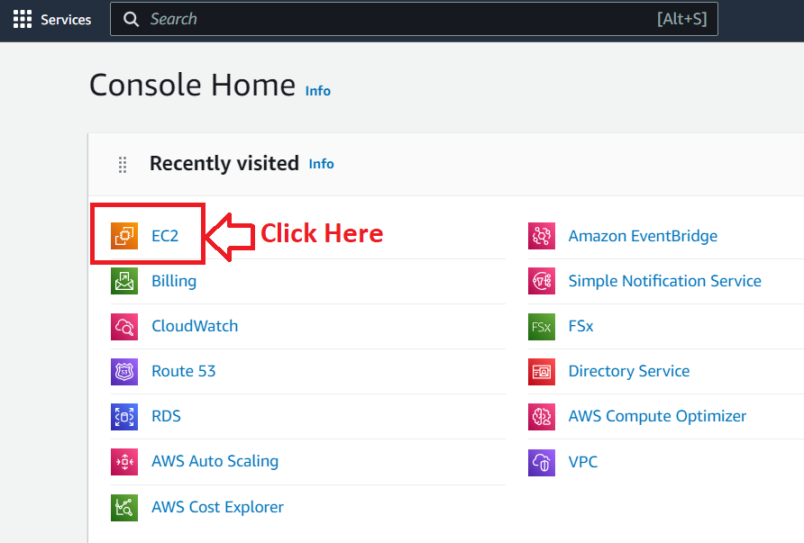

**Step 2: Go** to the **“Instances (running)”.**

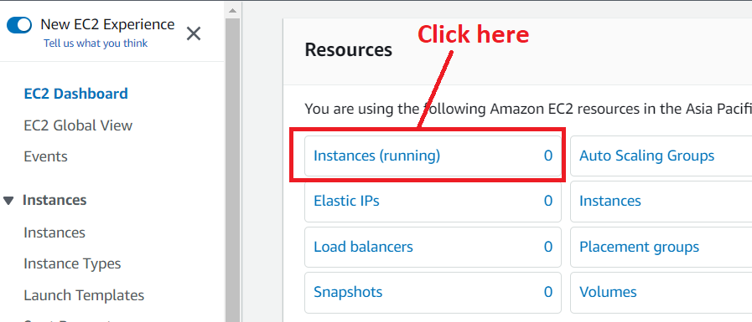

**Step 3: Click on the “Launch instances”.**

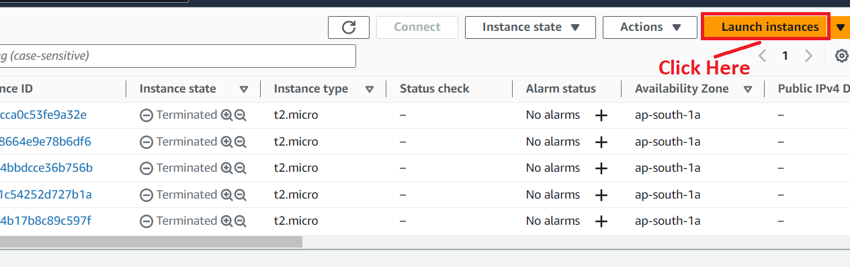

**Step 4: Write** the **Name** as **“AWS_EC2_Project1”** inthe **“Name”** under the **“Name and tags”** section.

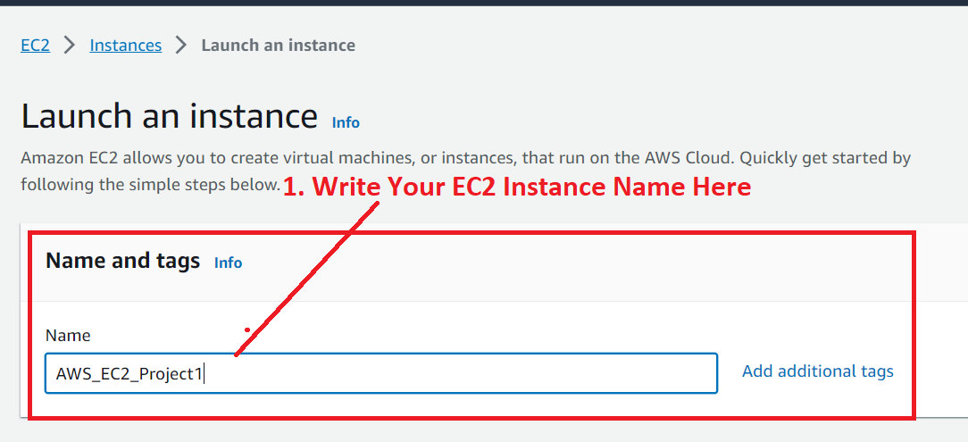

**Step 5: Choose** the **“Application and OS Images (Amazon Machine Image)”** as **“Ubuntu”.**

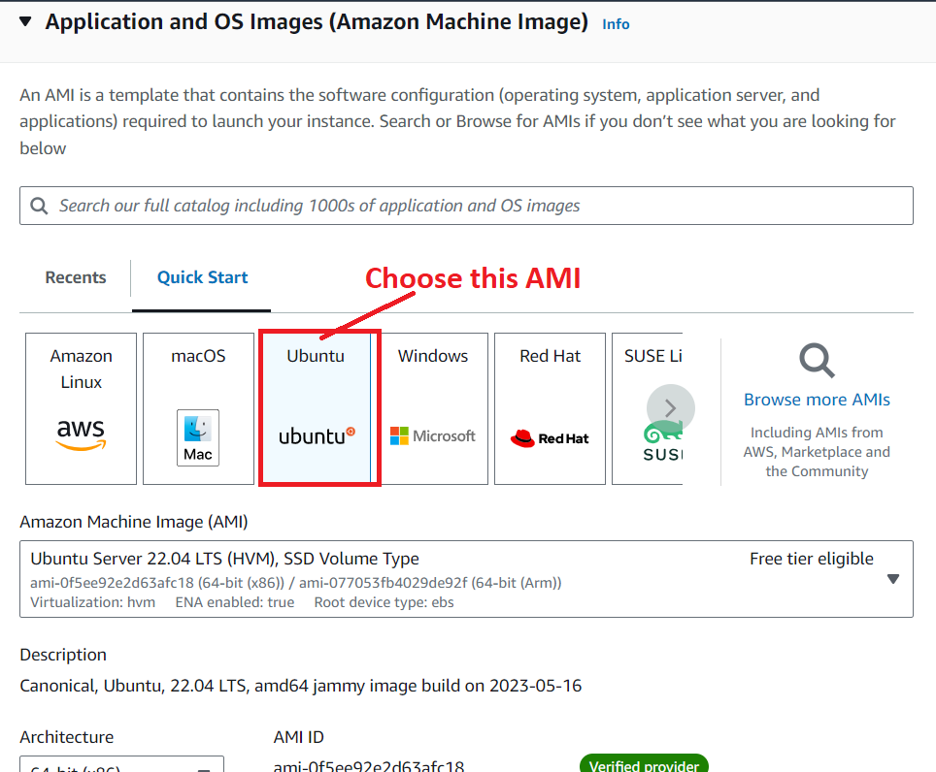

**Step 6: Choose** the **“Instance Type”** as **“t2.micro”.**

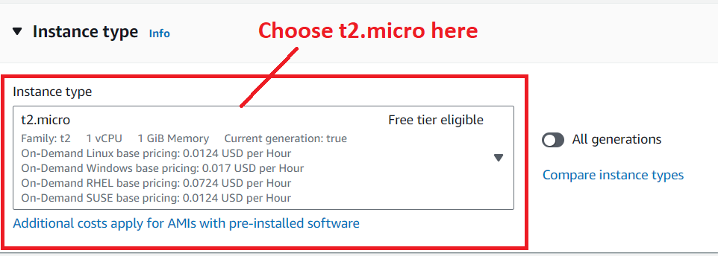

**Step 7: Choose** your **previously created login pair** (**“MY-WEB-SERVER”)** or **you** can **create** a **new “Key pair (login)” using** the **“Create new key pair” option.**

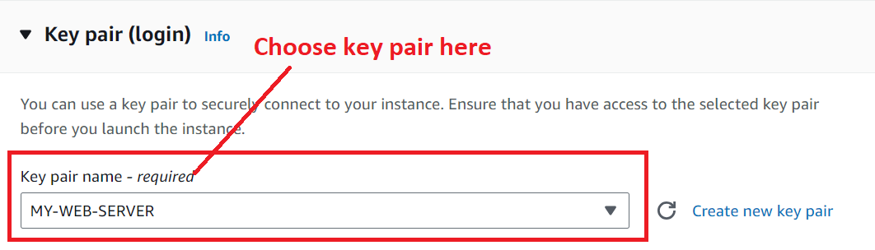

**Step 8: Click** on the **“Edit”** inthe **“Network Settings”.**

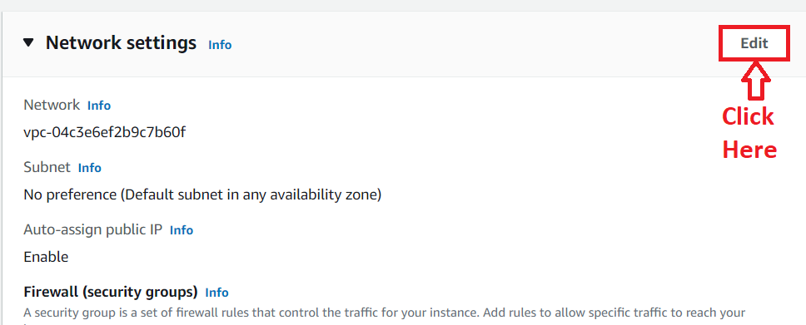

**Step 9: Choose** the **“Firewall (security groups)”** as **“Create security group”. While write** the **“Security Group Name and Description”** asthe **“AWS_EC2_Project1”.**

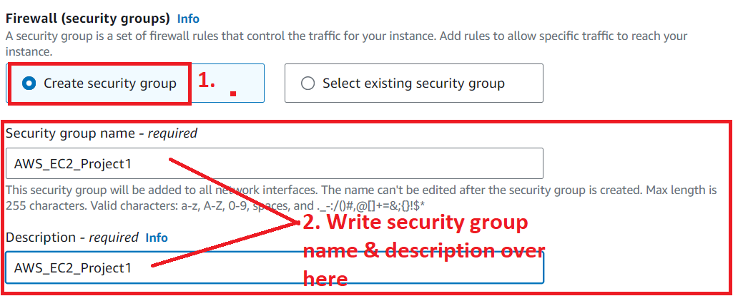

**Step 10: Now, we** will **give** the **“Inbound Security Group Rules” one by one.**

**a. First, we** will **choose** the **“Type”** as **“SSH”** &the **“Source Type”** as **“Anywhere”.**

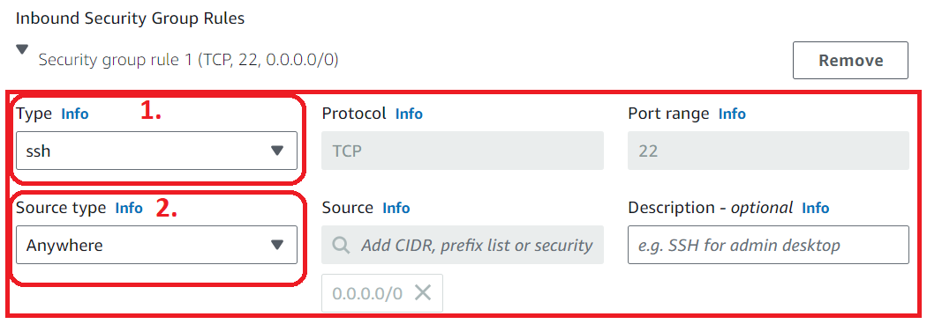

**Click** on the **“Add security group rule”.**

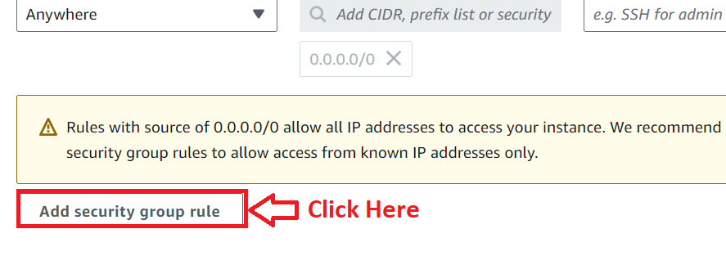

**b. Second, we** will **choose** the **“Type”** as **“HTTP”** & the **“Source Type”** as **“Anywhere”.**

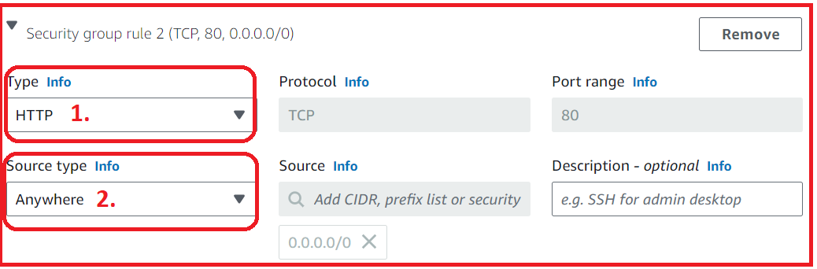

**Click** on the **“Add security group rule”.**



**c. Third, we** will **choose** the **“Type”** as **“MySQL/Aurora”** & **“Source Type”** as **“Anywhere”.**

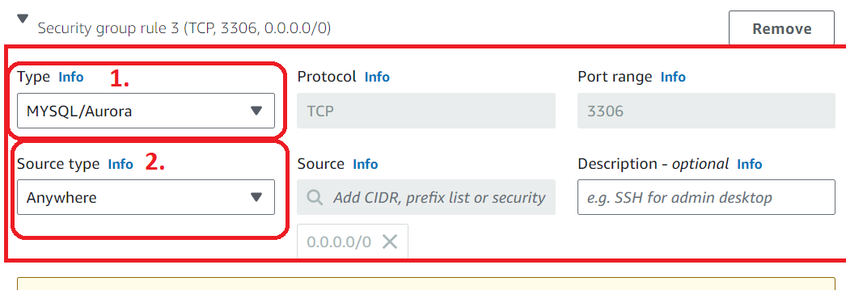

**Step 11: Click** onthe **“Launch Instance”.**

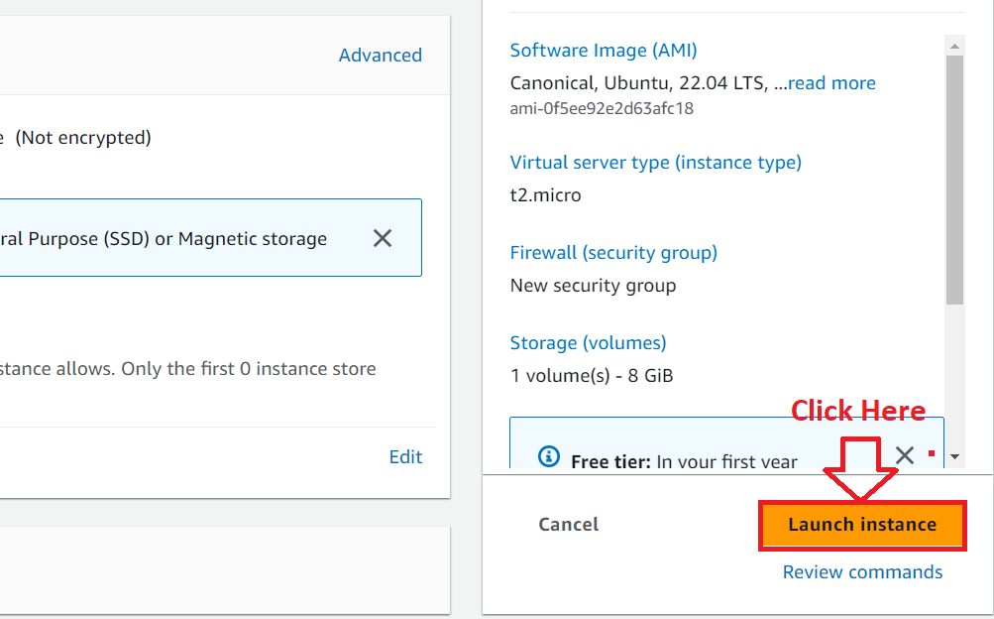

**Step 12: The instance** will be **started launching.**

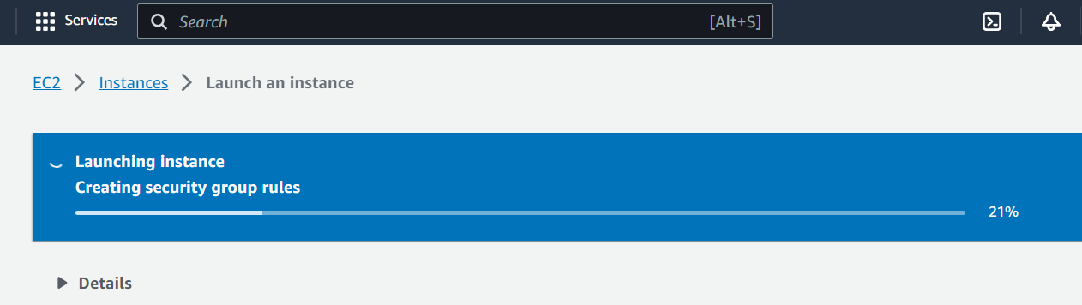

**Step 13: The instance [AWS_EC2_Project1]** will be **launched successfully. Click** on **the “Hyperlink”.**

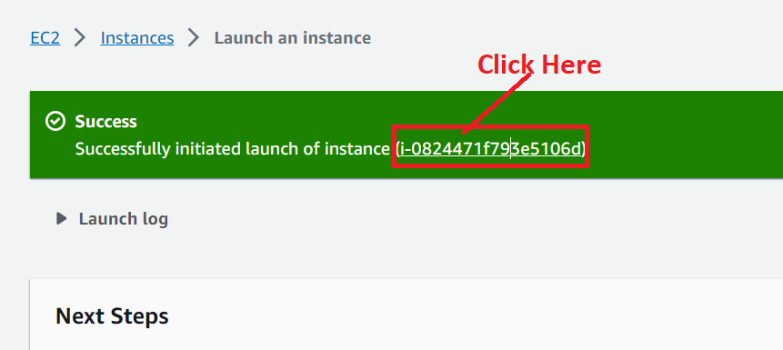

**Step 14: First, the instance** will be **in** the **“Pending” state.**

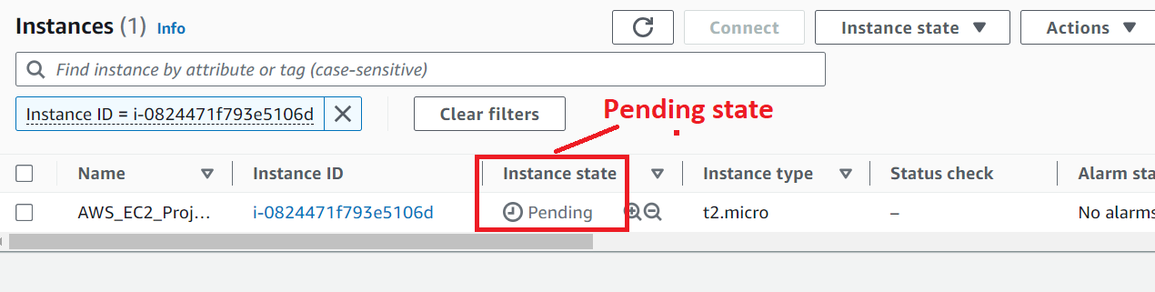

**Step 15: It** will be **in** the **“Running State”** after **sometime.**

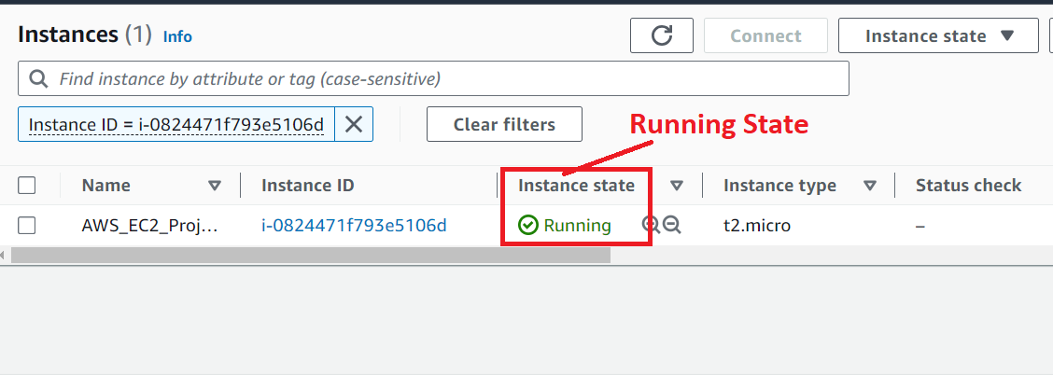

**Step 16: Select** the **instance [AWS_EC2_Project1]** & **click** onthe **“Connect”.**

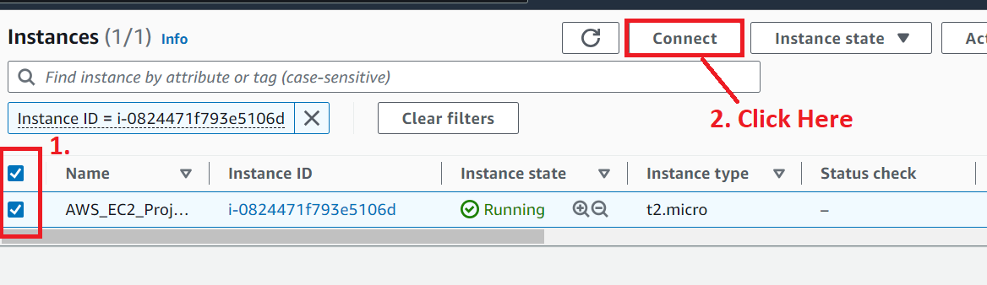

**Step 17: Click** on the **“Connect”** in the **“EC2 Instance Connect”. We** will be **doing all** the **operation** from the “**AWS EC2 Instance Connect”** option.

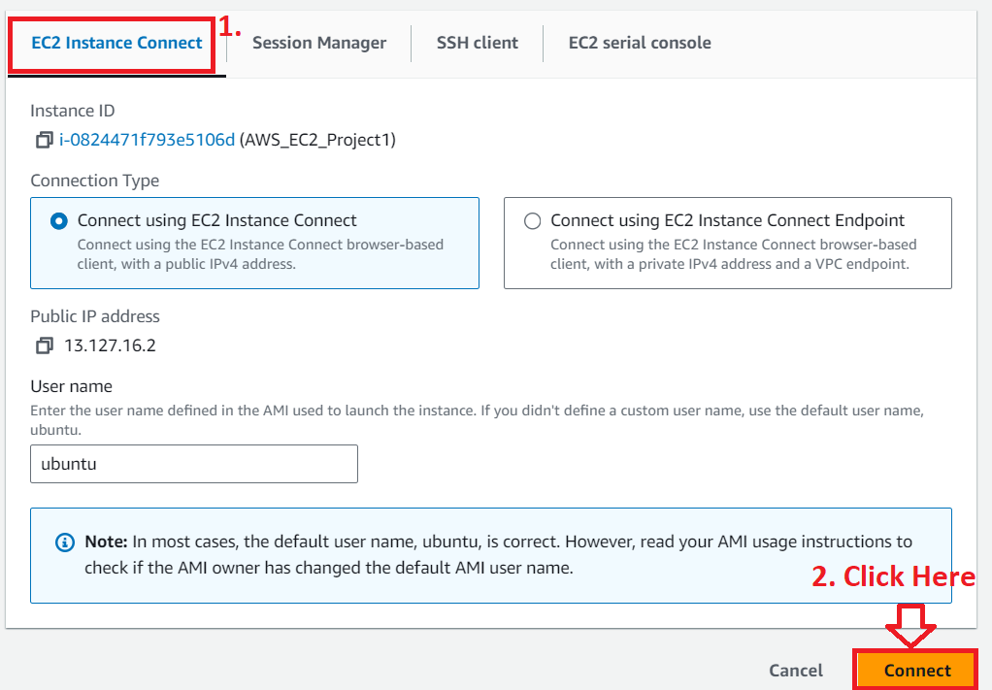

**Step 18: You** will be **successfully connected** to your **machine.**

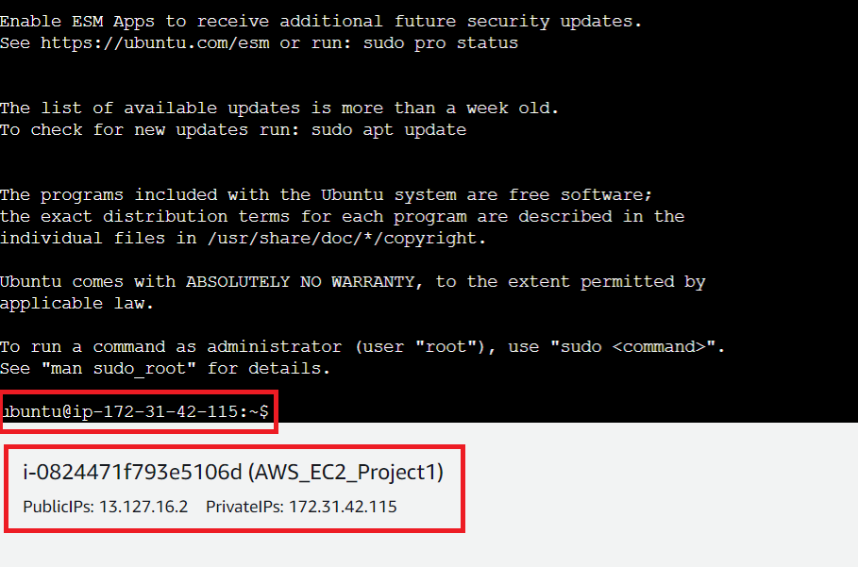

**Step 19: First, we** will **update** the **"AWS_EC2_Project1" machine using** this **command: “sudo apt update”.**

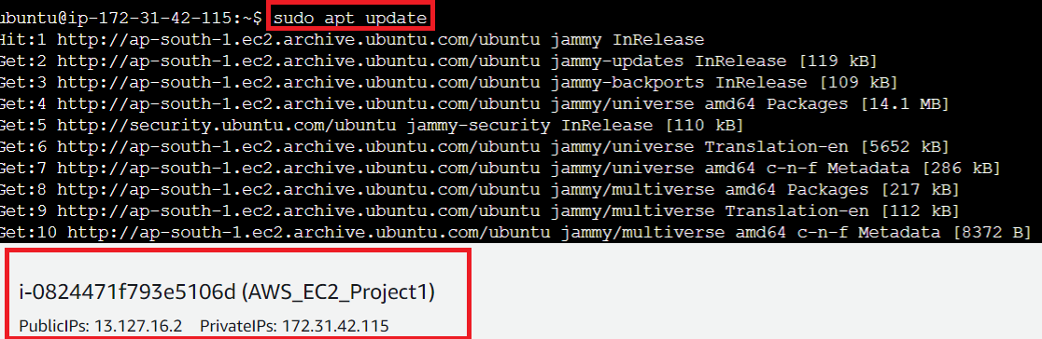

The **“Ubuntu machine [AWS_EC2_Project1]”** will be **successfully updated.**

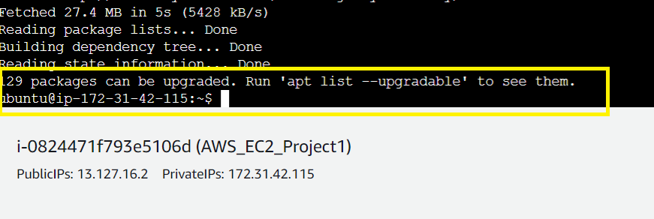

**Step 20: Now, we** will **install the “apache2” web server** over **here** to **run** the **“PHP” website. Use** this **command (sudo apt install apache2 -y)** to **install** the **Apache web server.**

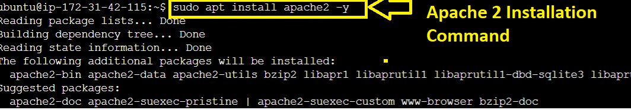

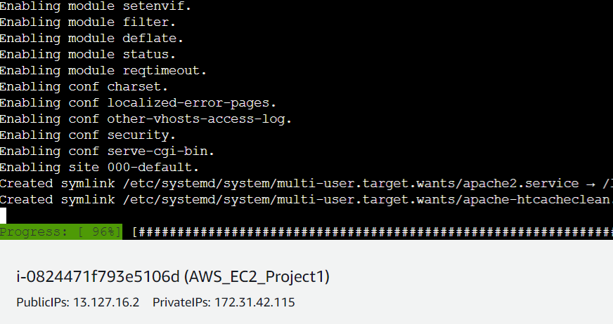

**Step 21: The apache2 server** will be **successfully installed.**

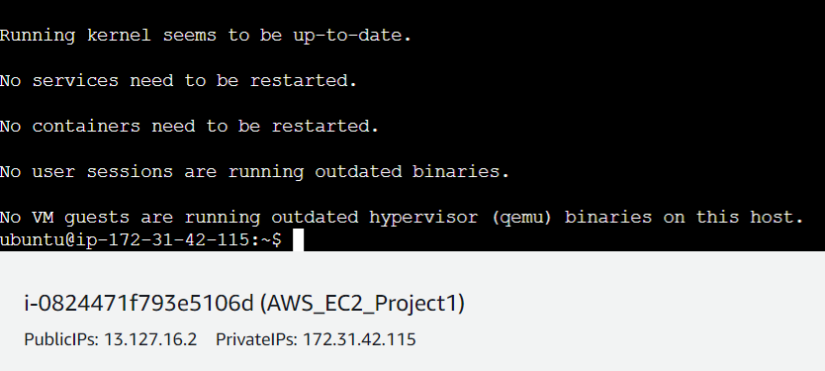

**To check that Apache2 web server** has been **successfully installed** or **not, copy** the **“Public IP Address (13.127.16.2)”** & **paste** it into the **browser address bar. You** will **notice that “Apache2 Web Page”** will be **successfully shown.**

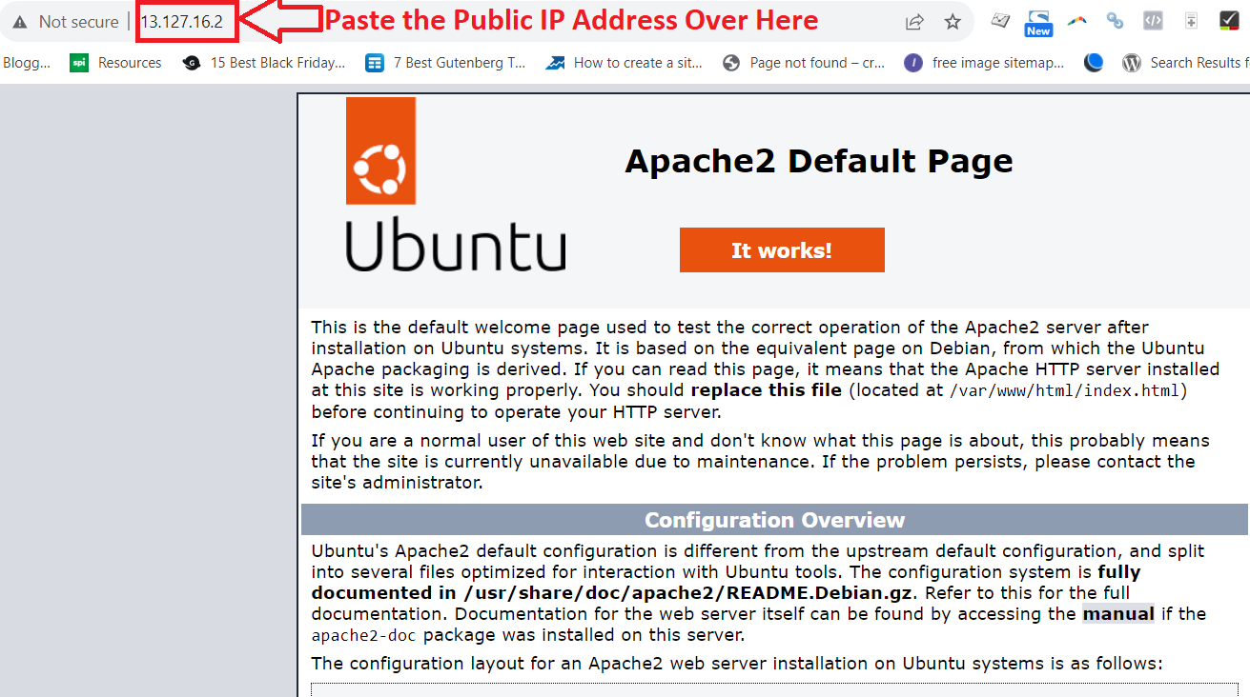

**2. Deploy the PHP Website on EC2 Server**

**Step 1: First, we** will **remove** the **index.html file** & **create** a **new index.php** file. Go to the **“html”** directory **using** the command: **“cd /var/www/html”**.

**You** will **go inside** intothe **html directory.**

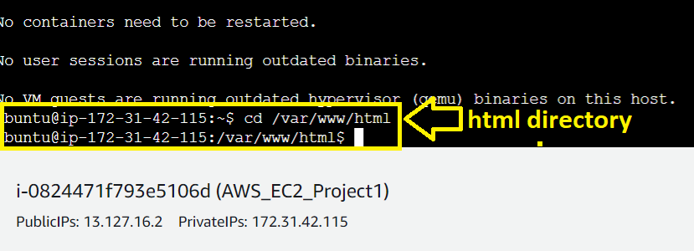**Step 2: Run** the **command “ls”** & **you** will **notice** that **“index.html” file** will be **present over here.**

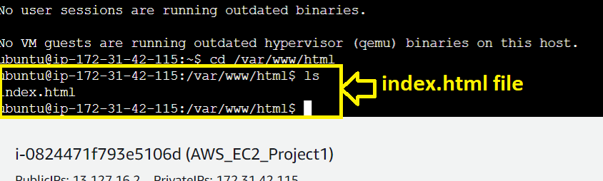

**Step 3: Remove** the **index.html file using** the **command:- “sudo rm index.html”. Do “ls”** & **you** will **notice** that **there** is **no “index.html” file present** over **here. Press “enter”** fromthe **keyboard after typing** the **command.**

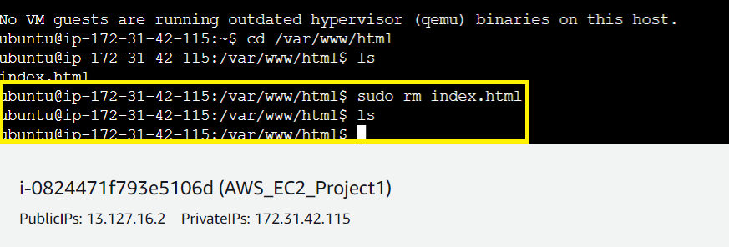

**Step 4: Create** an **“index.php” file using** the **command: - “sudo nano index.php”. Press “Enter”** from **keyboard after typing the command.**

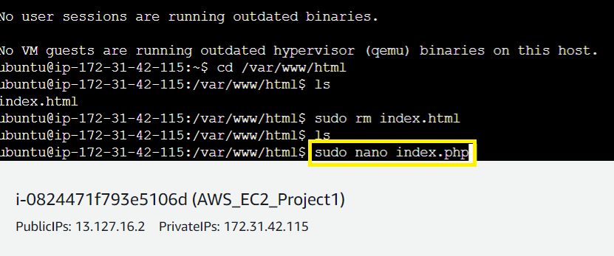

**Step 5: A file Editor** will be **opened** & **paste** the **“PHP Website Code”** over **here.**

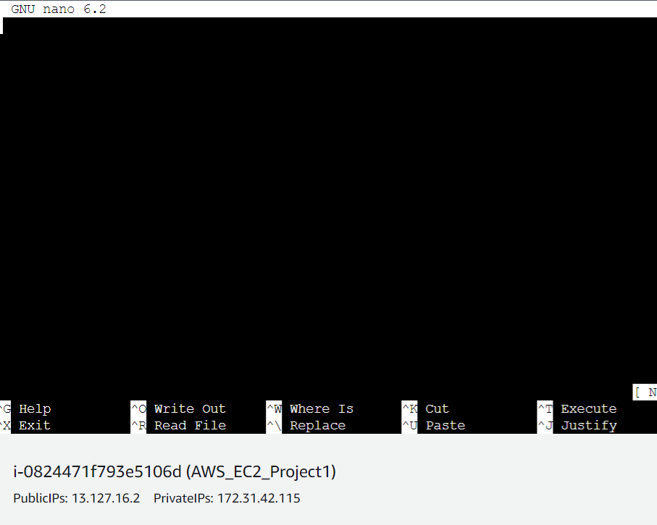

**Step 6: This** is a **sample PHP web page code which we** will **paste it** into the **“Nano Editor”. Copy** this **PHP web page code.**

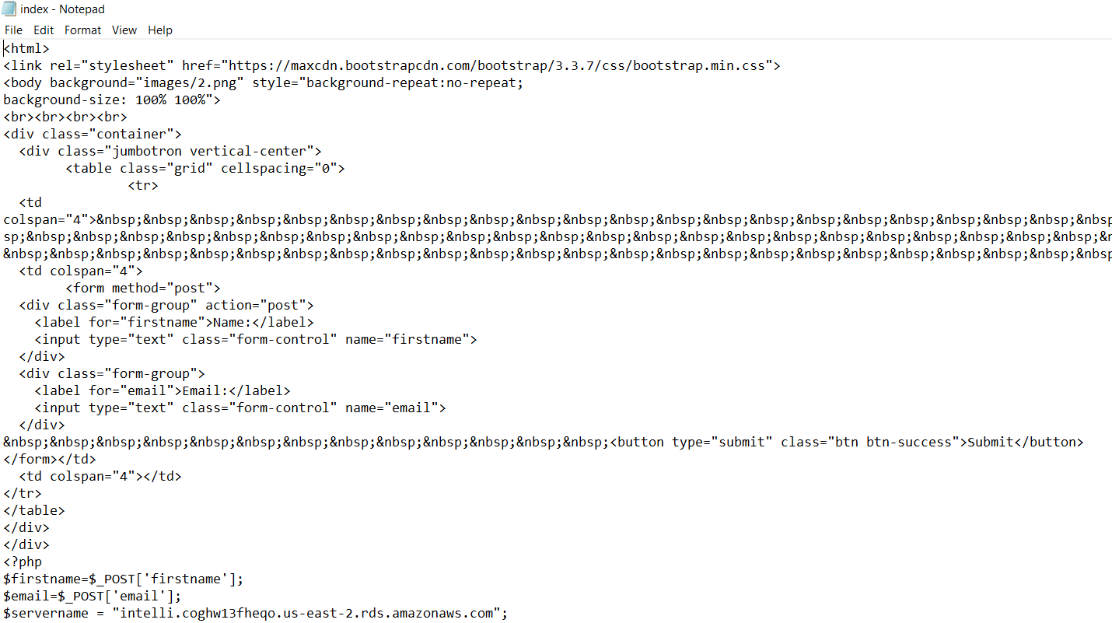

**Step 7: Paste** the **above code** into the **“Nano Editor”.**

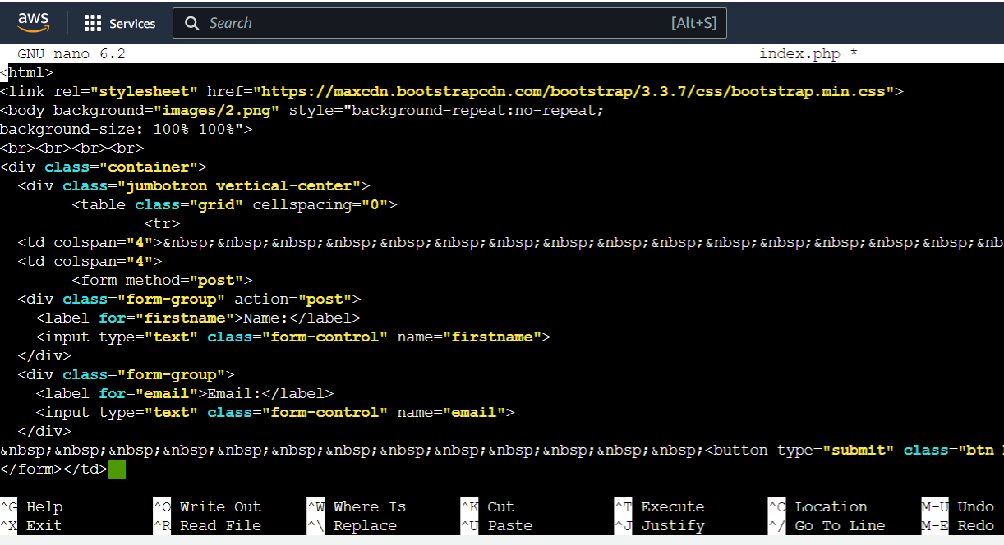

**Step 8: Do “CTRL+S”** to **save** & **do “CTRL+X”** from **exiting** the **editor. You** will be **successfully exited** from the **“Nano Editor”.**

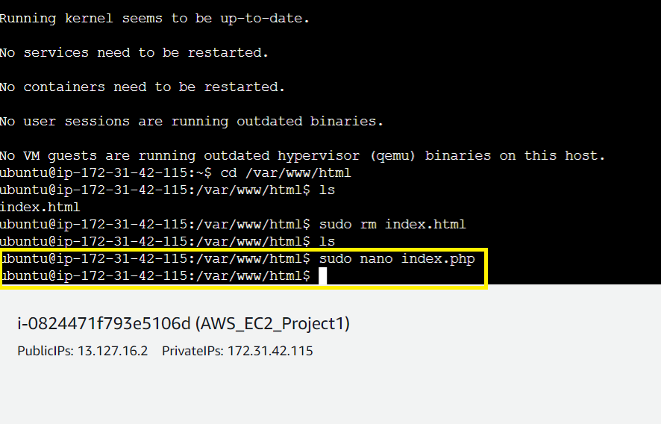

**Step 9: Paste** the **“Public IP Address (13.127.16.2)”** inthe **“Browser Address Bar”** & **press “enter” from the keyboard. A “PHP Web Page”** will be **shown.**

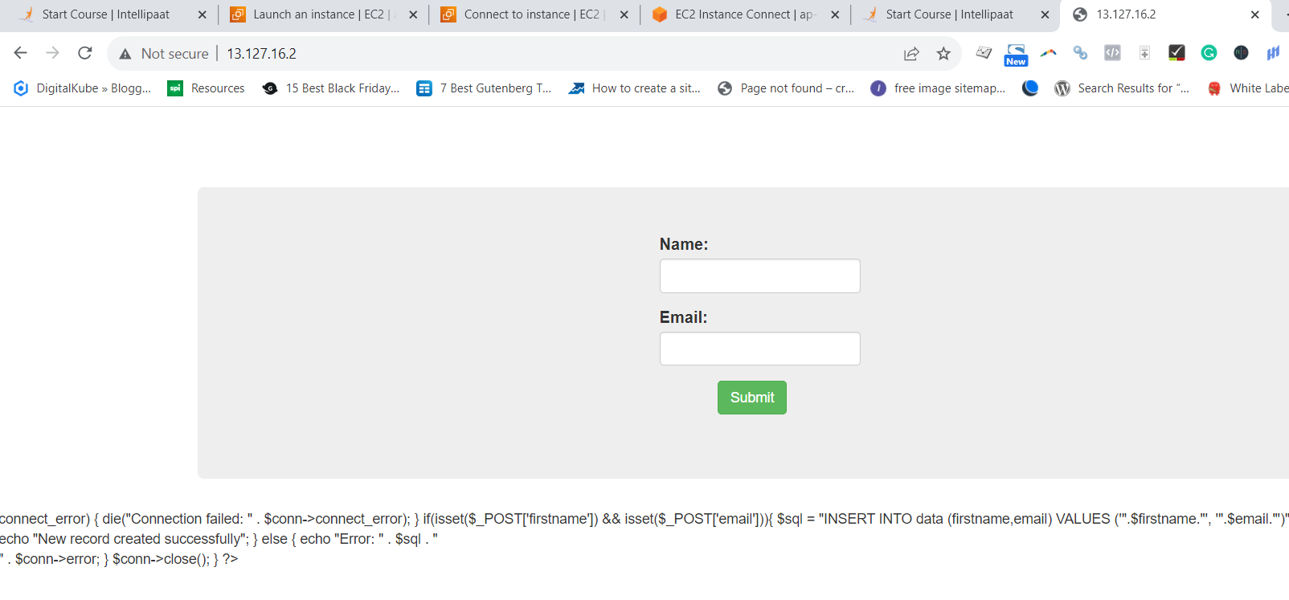

**3. Create a MySQL Database & Set Up Connection Over EC2 Server with Proper Tesing**

**A. Create a MySQL Database**

**Step 1: Go** tothe **“Services” section** & **Search** the **“RDS”** over **Here. Put** the **cursor** over **“RDS”** & **click** on the **“Databases”.**

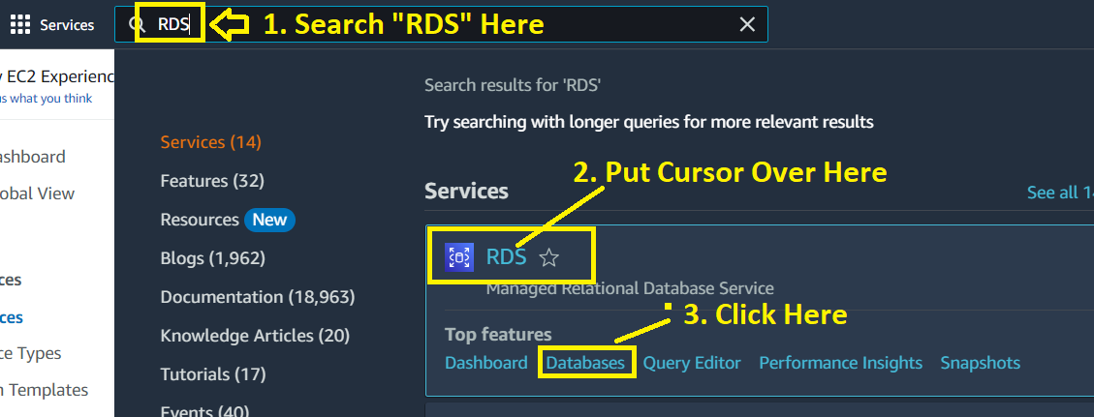

**Step 2: Click** onthe **“Create database”.**

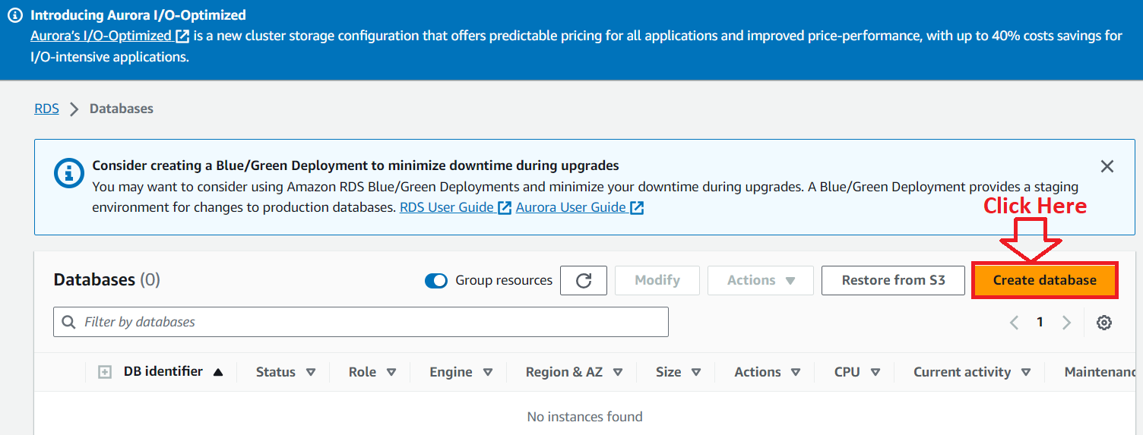

**Step 3: In** the **“Create Database” option, choose** the **“Standard create”** as **“Choose a database creation method”** &the **“Engine Options”** as **“MySQL”.**

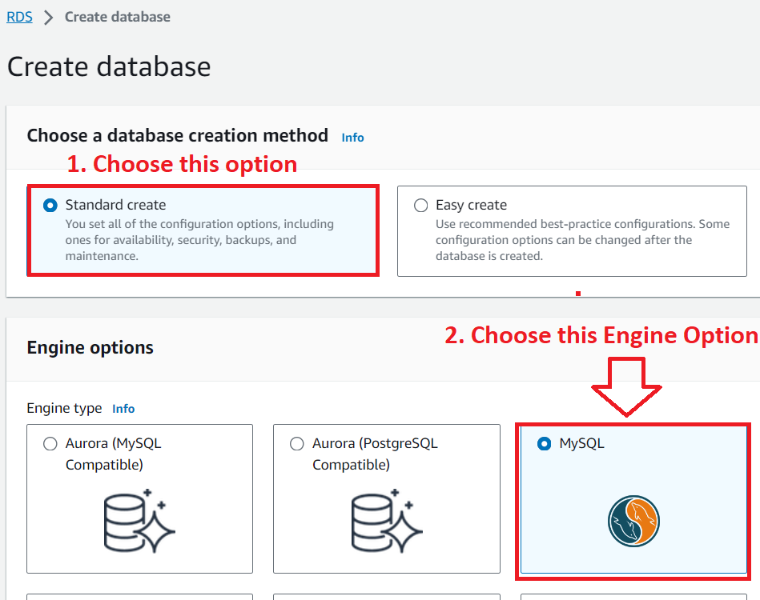

**Step 4: While leave** the **“SQL Version (MySQL 8.0.33)”** as it is.

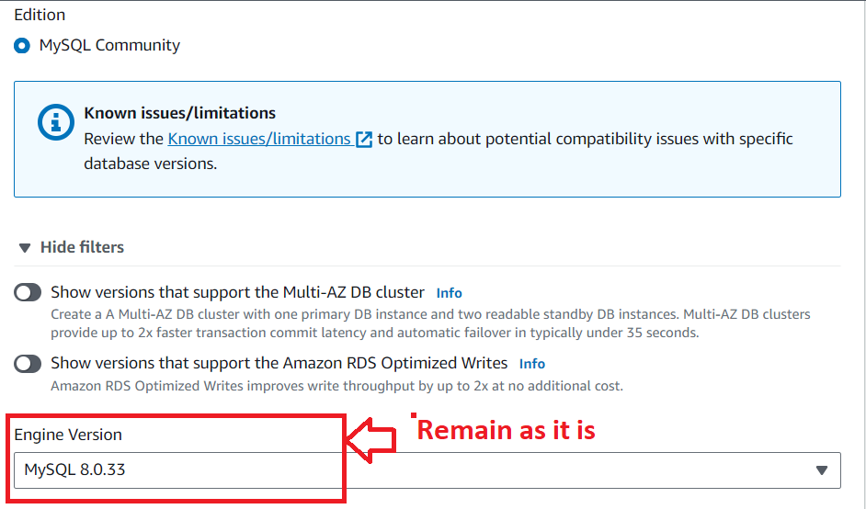

**Step 5: Choose** the **“Templates”** as the **“Free Tier”.**

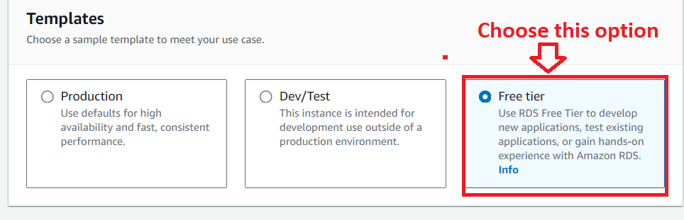

**Step 6: Rename** the **“DB Instance Identifier”** asthe **“application-database”.**

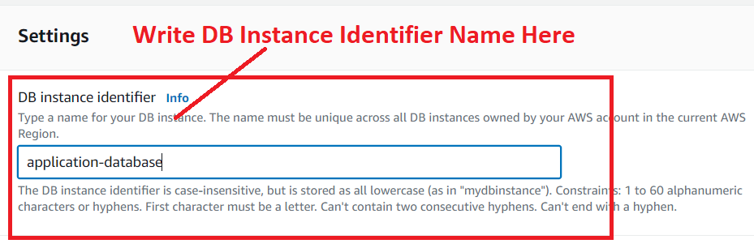

**Step 7: In** the **“Credential Settings”, write** the **“Master username”** as **“admin”** &the **“Master Password”** as **“intel123”.**

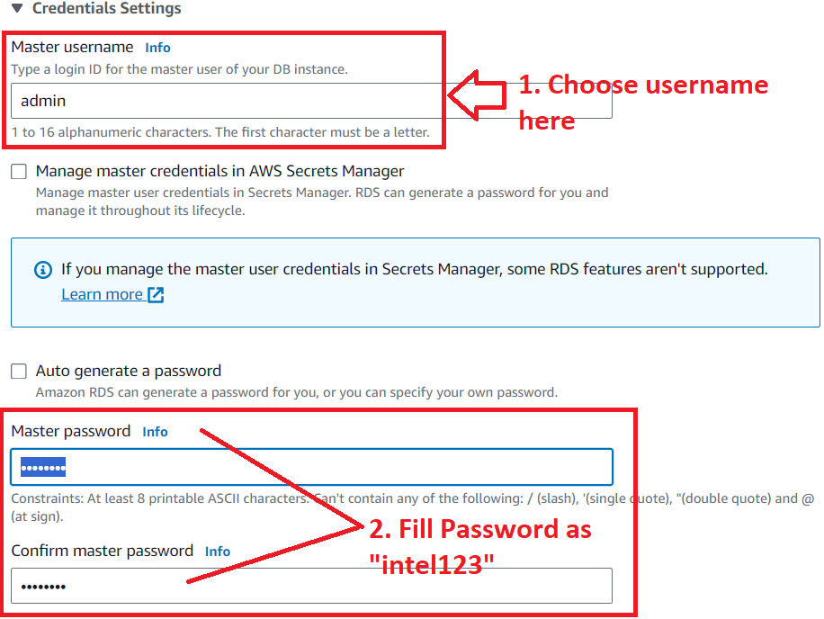

**Step 8: Choose** the **“DB instance class”** as the **“Burstable classes (includes t classes)** asthe **“db.t3.micro”** in the **“Instance Configuration”** section.

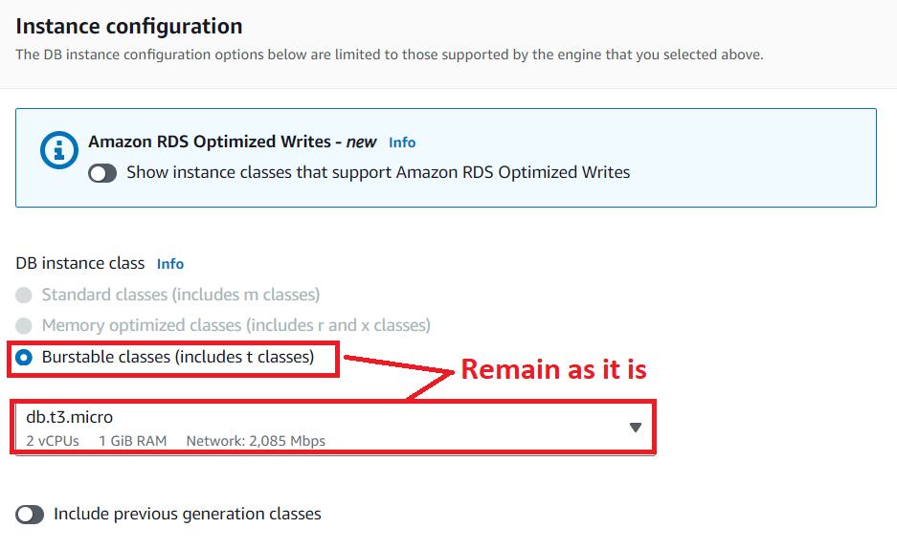

**Step 9: While leave** the **“Storage” Configuration as it is. Disable** the **“Storage autoscaling”** by **unselecting** the **“Enable storage autoscaling”.**

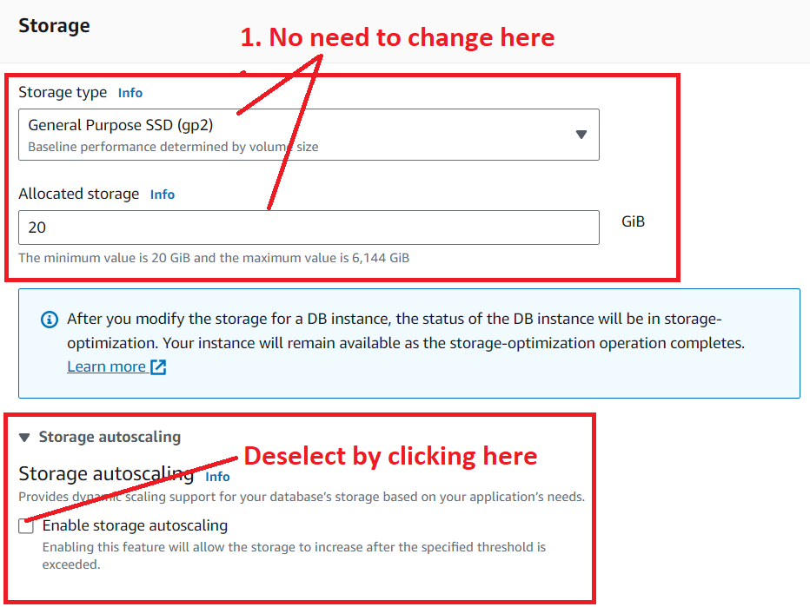

**Step 10: In** the **“Connectivity”** section, **choose** the **“Compute resource”** as **“Connect to an EC2 compute resource”. Choose** your **“EC2 Instance (AWS_EC2_Project1)”** here.

**c**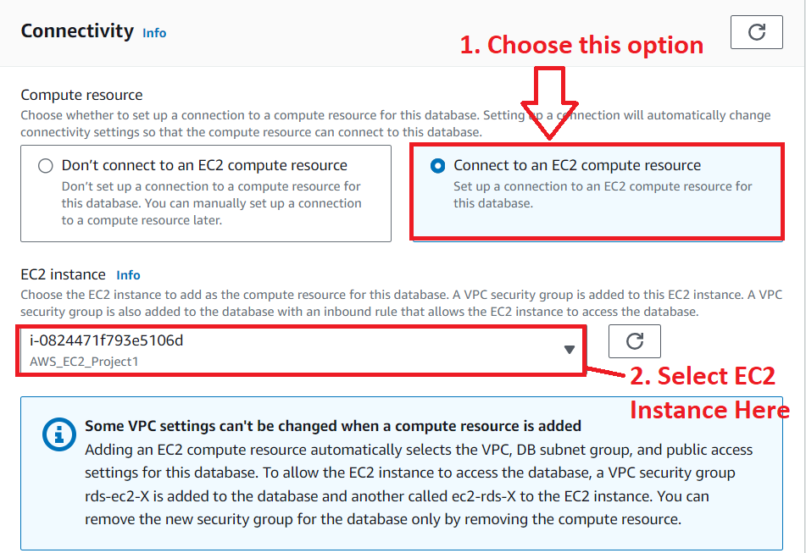

**Step 11: Choose** the **“DB subnet group”** asthe **“Automatic setup”.**

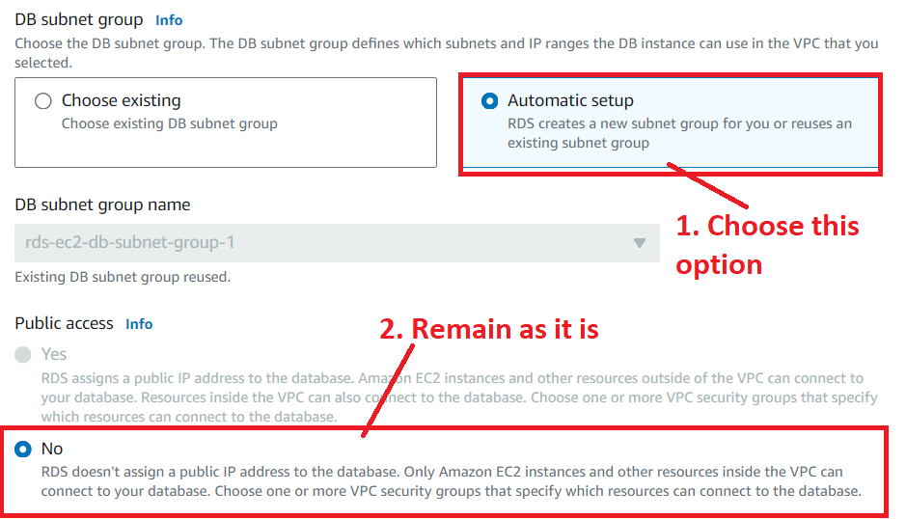

**Step 12: Choose the “VPC security group (firewall)”** as the **“Choose existing”, while** the **“Additional VPC security group”** asthe **“AWS_EC2_Project1”.**

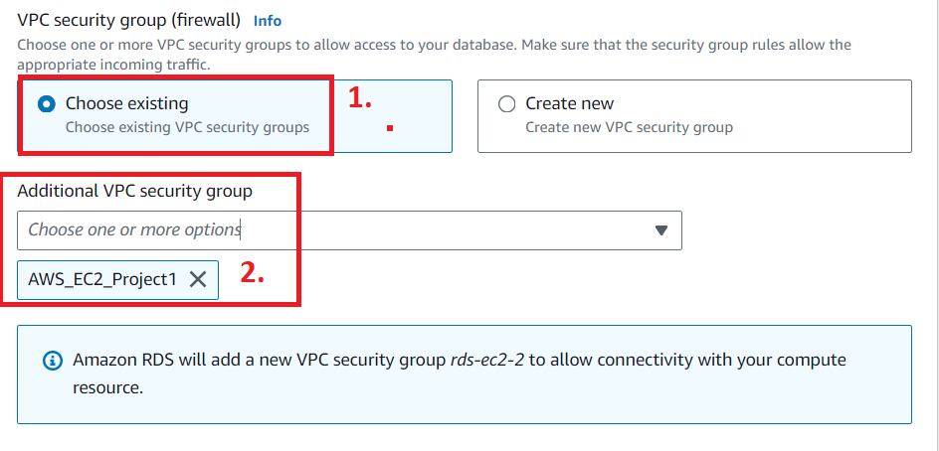

**Step 13: While leave** the **"Database authentication options"** as **by default** the **"Password authentication".**

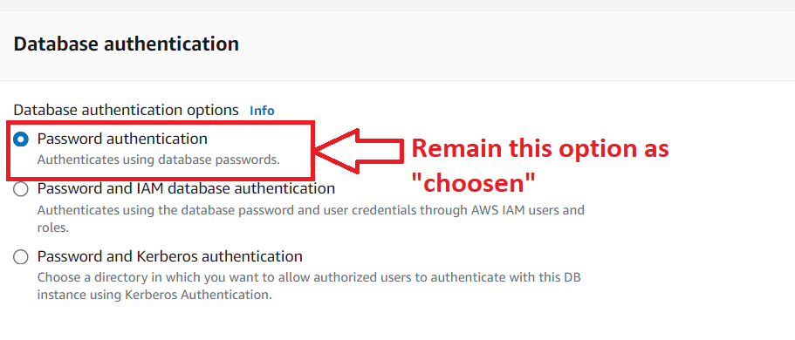

**Step 14: Go** tothe **“Additional Configuration”** & **put** the **“initial database name”** as **“intel”. Disable** the **other features** such as **“Backup”, “Encryption”** & **“Maintenance”. Because they** are the **chargeable options.**

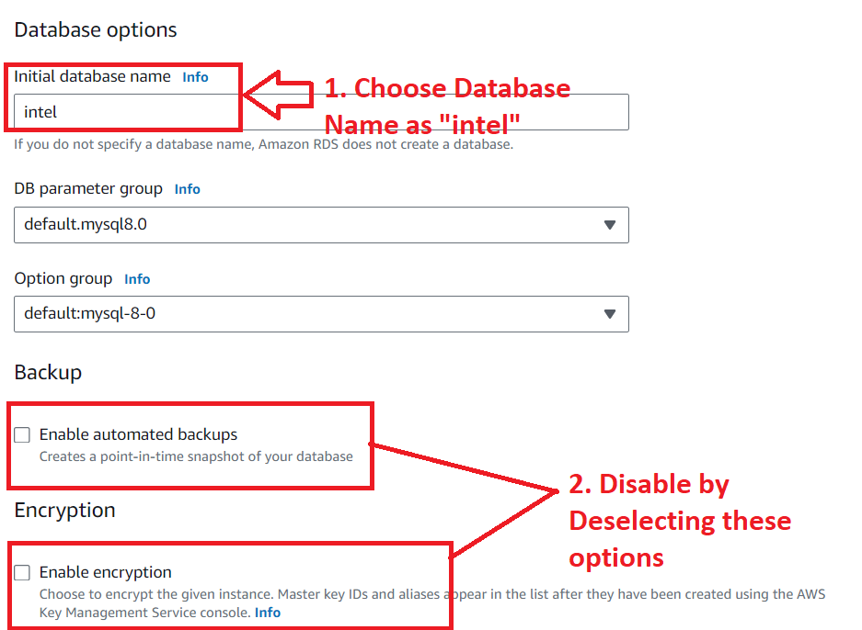

**Step 15: Click** onthe **“Create database”.**

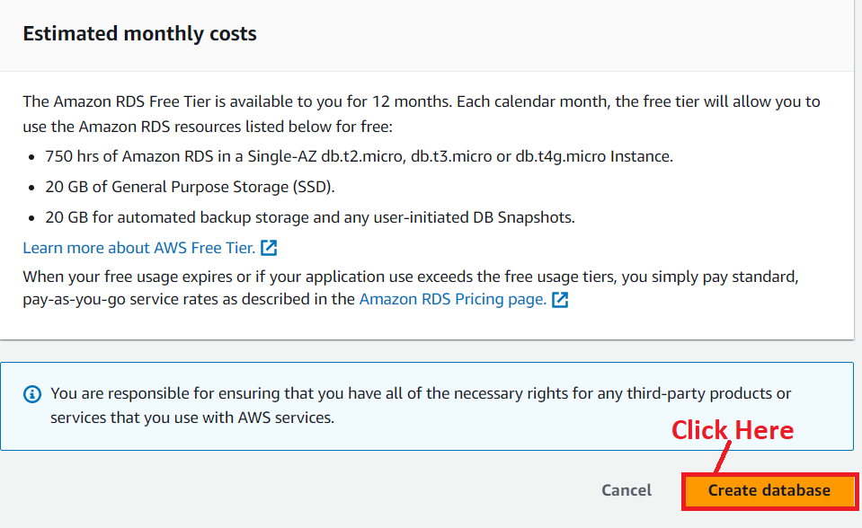

**Step 16: The database [application-database]** will be **started creating. It** will **take some time** to **setup.**

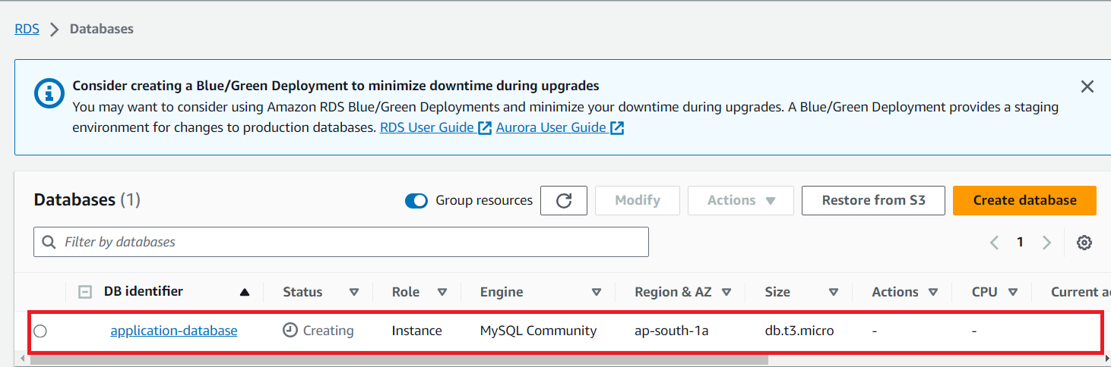

**Step 17: After sometime, the database “Status”** will be **shown** as **“Available”.**

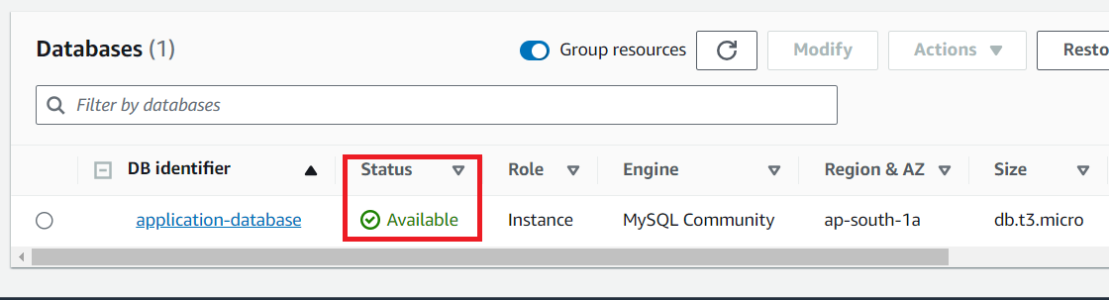

**Step 19: Click on “application-database” hyperlink. You will get all the database information.**

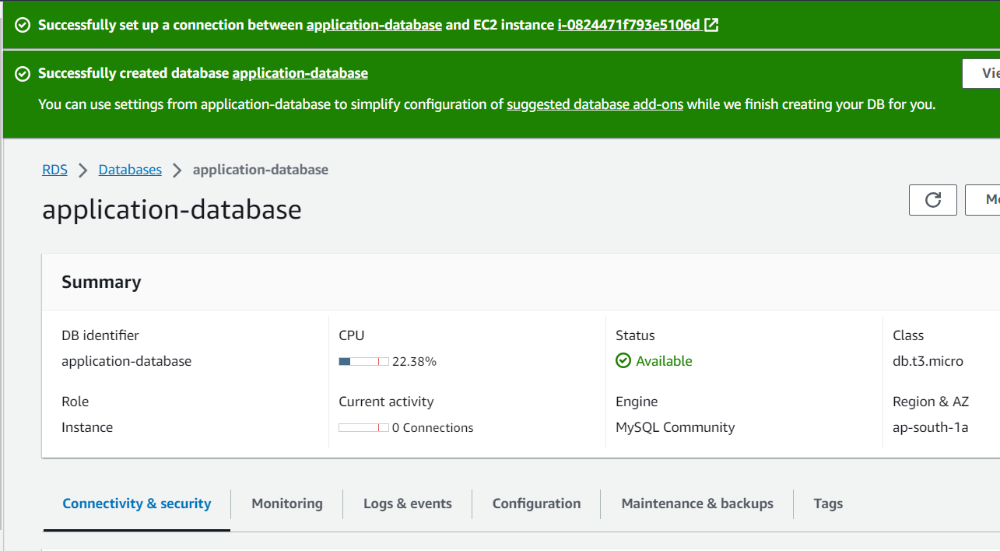

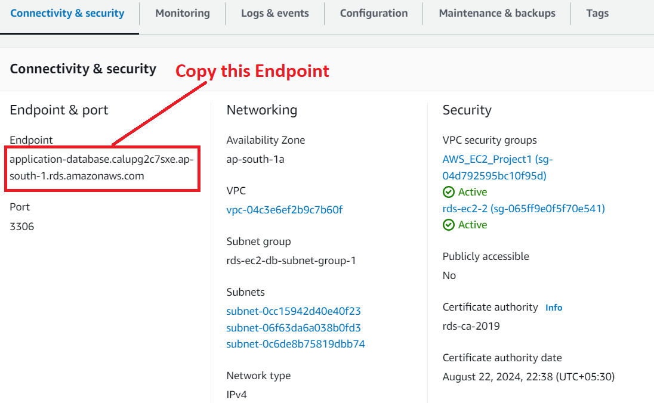

**B. Set Up Database Connection with EC2 Server & Test the Created Database Over Here**

**Step 1: First, we** have to **install “MySQL”** over **“EC2” server** using this **command:- “sudo apt install mysql-server -y”. MySQL server** will be **successfully installed.**

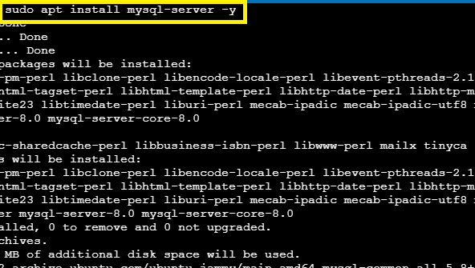

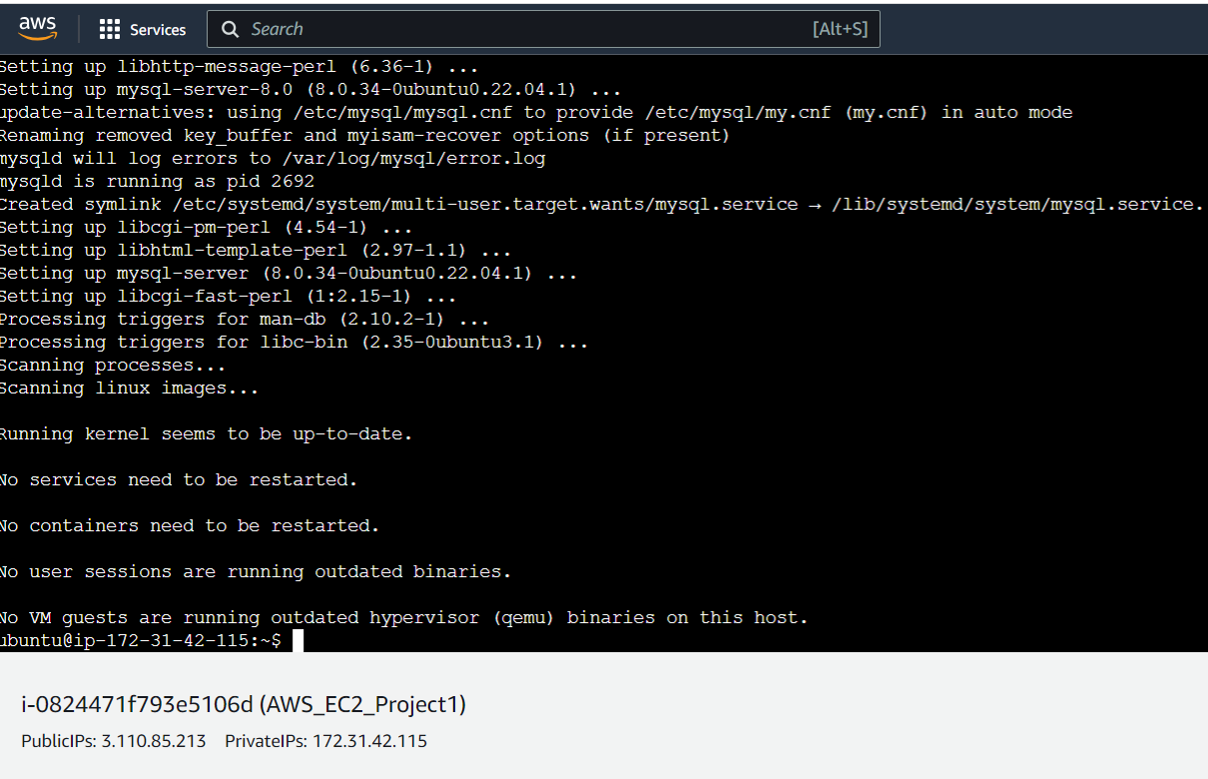

**Step 2: First, you** have to **change** the **directory. Go** tothe **html directory using** the **command:- cd /var/www/html.**

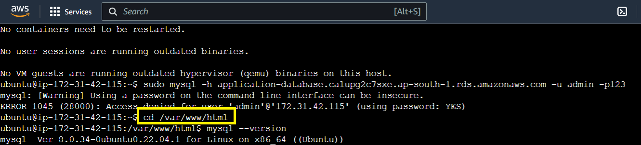

**Step 3: Now, we** will **set up** the **MySQL database connection** with the **EC2 server** using this **command: - *“sudo mysql -h application-database.calupg2c7sxe.ap-south-1.rds.amazonaws.com -u admin -pintel123”.***

**It** will be **successfully connected** with the **EC2 server.**

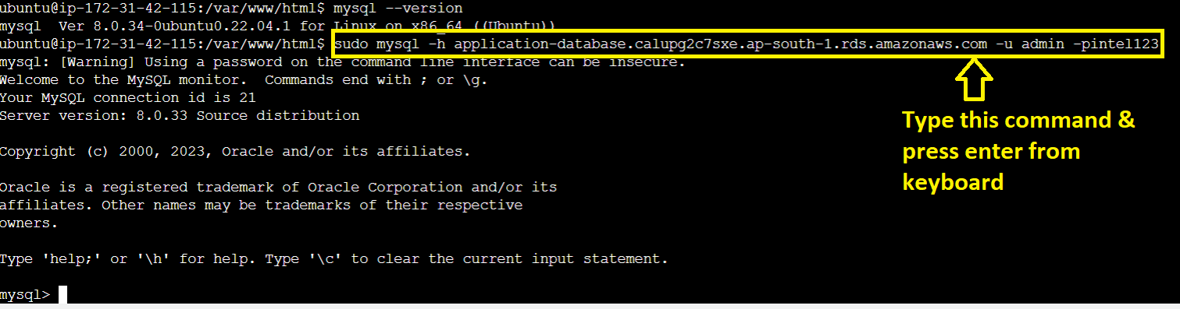

**Step 4: Now, type** the **command “show databases”, it will show** all the **created databases** here. **We** have **created** a **database named** with **“intel”. You** will **notice** this **database after typing** the **above query.**

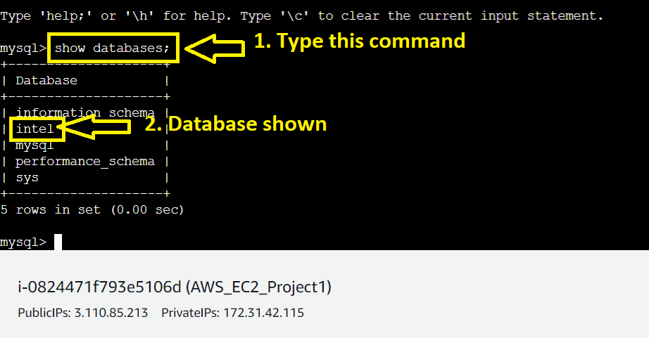

**Step 5: Now, go** to the **“intel” database. Write** the **command (“use intel”)** here. **Now, we** will be **inside** the **“intel” database.**

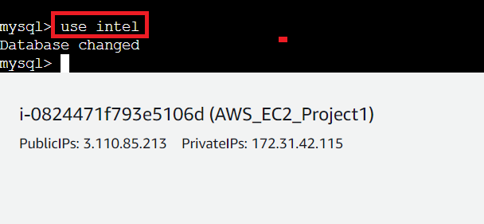

**Step 6: Now, we** will **create** a **table named** as **“data”** with **provided fields according** to the **“PHP source code”. In** the **PHP file, only** the **“firstname & email”** has been **given.**

**Use the following query to create a table: “create table data (firstname varchar(20), email varchar(20));”.**

**The table** will be **successfully created.**

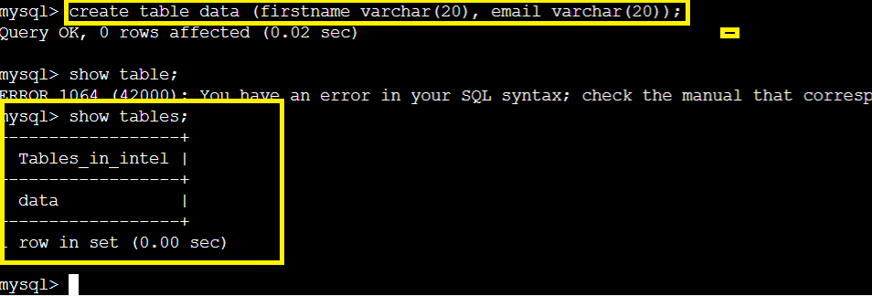

**Step 7: Now, we** will **insert** the **value into** the **data table using** the **following query: insert into data values (‘AWS’, ‘support@aws.com’);**

**Your query** will be **successfully executed.**

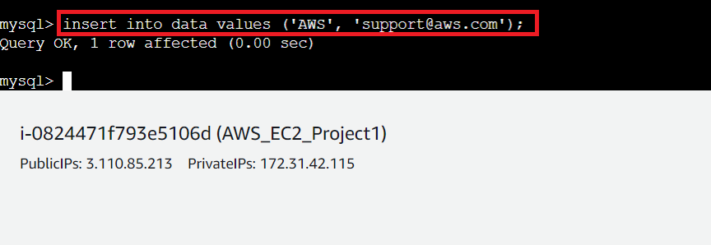

**Step 8: If you** want to **check that data** is **successfully inserted** or **not, type** this **query: select * from data;**

***You*** *will* ***notice that your query*** *has been* ***successfully inserted.***

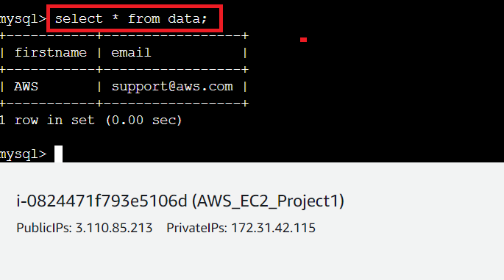

**Step 9: Now, we** are **exiting from** the **database using** the **“exit” command.**

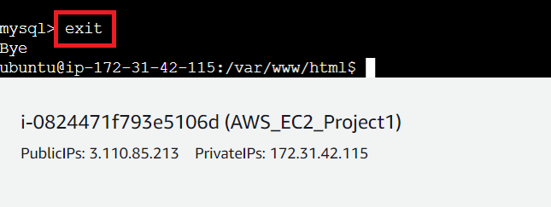

**C. Configure the Correct Database Settings in PHP file & Insert Dependencies to Remove the Error from PHP Web Page**

**1. Configure the Right Database Settings in the PHP File**

**Step 1: Open** the **“index.php” file using** the **following command:- “sudo nano index.php”.**

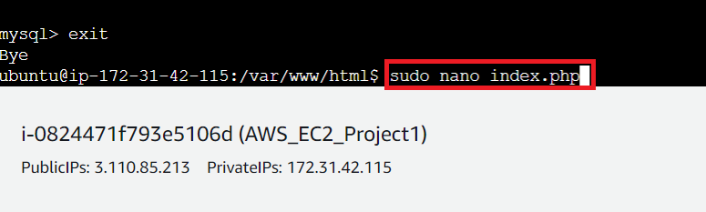

**Step 2: The “index.php” file** will be **opened. Scroll down & do these two settings** for **setting up** the **right database connection:**

**servername = “Real Database Endpoint (application-database.calupg2c7sxe.ap-south-1.rds.amazonaws.com)”**

**username = “admin” instead of “intel”.**

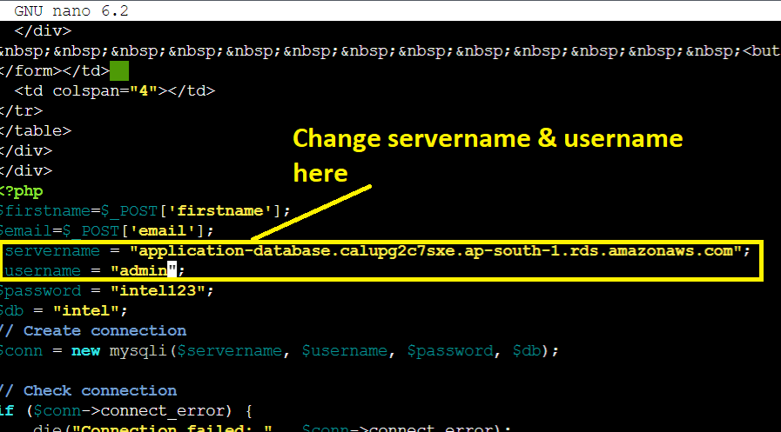

**Step 3: Do CTL+S** to **save** & **do CTRL+X** to **exit from** the **index.php** file**.**

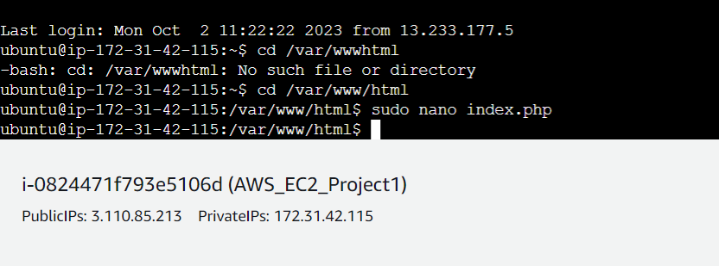

**Step 4: When we open** the **web page** by **typing** the **public IP address [13.127.16.2] in** the **browser address bar. You** will **notice the database connection error** over **here.**



**Now, we** will **remove** this **error** in our **second step.**

**2. Install the PHP MySQL Database Dependencies to Remove the Error from WebPage**

**Step 1: Copy** the below-given **php repository command** & **paste it** into the **machine** & **press “enter” from** the **keyboard.**

**Command:- “sudo add-apt-repository -y ppa:ondrej/php”.**

**The “PHP repository”** will be **successfully added.**

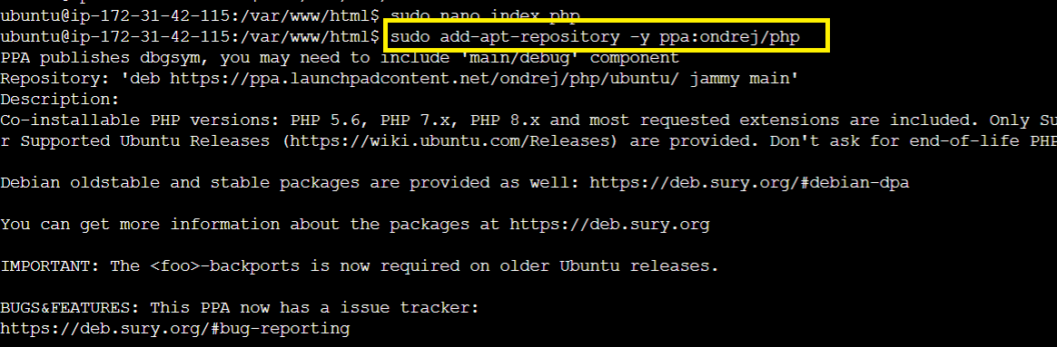

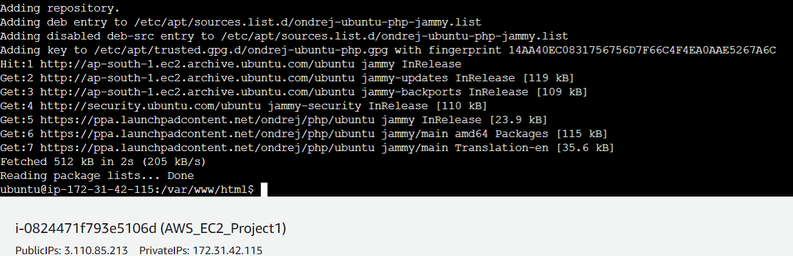

**Step 2: Now, install** the **mysql-client over** the **“EC2 Machine [AWS_EC2_Project1]”** using this **command:- “sudo apt install php5.6 mysql-client php5.6-mysqli”. Press “enter”** from **the keyboard** to **execute** the **command.**

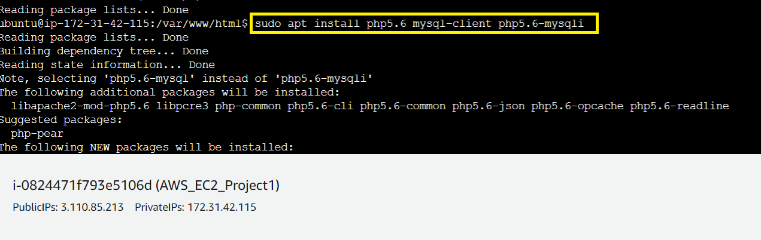

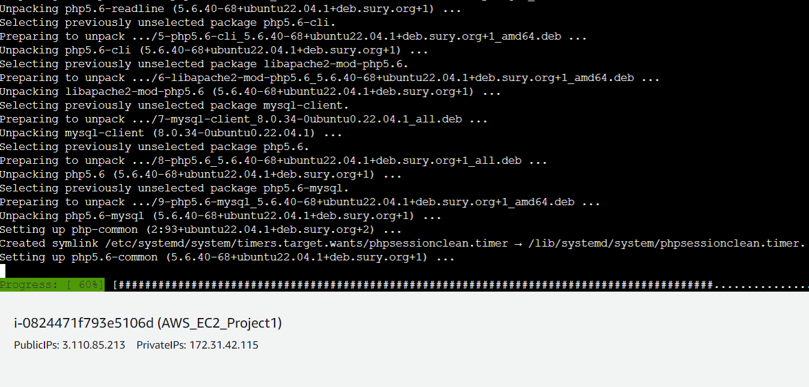

**Step 3: The PHP & MySQL dependencies** will be **successfully installed. Check** your **web page** by **refreshing** the **button.**

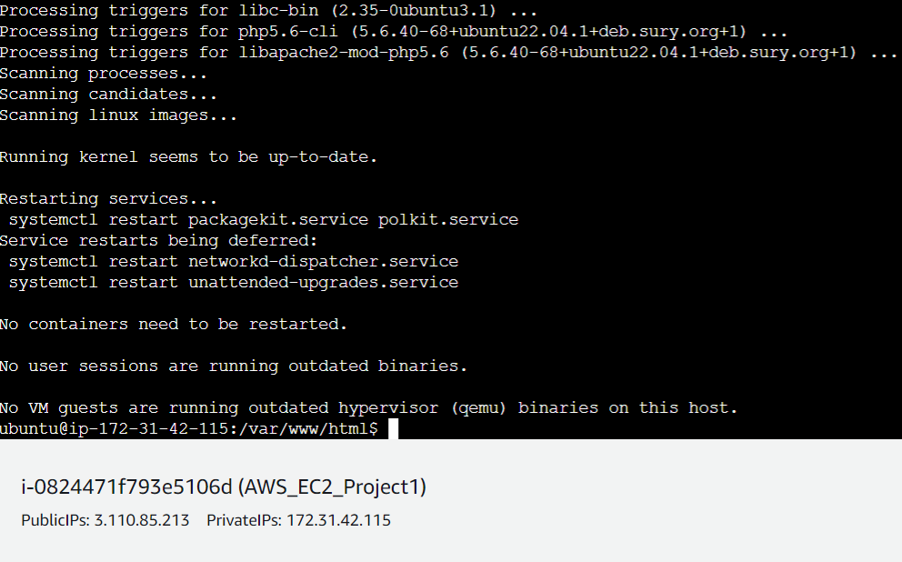

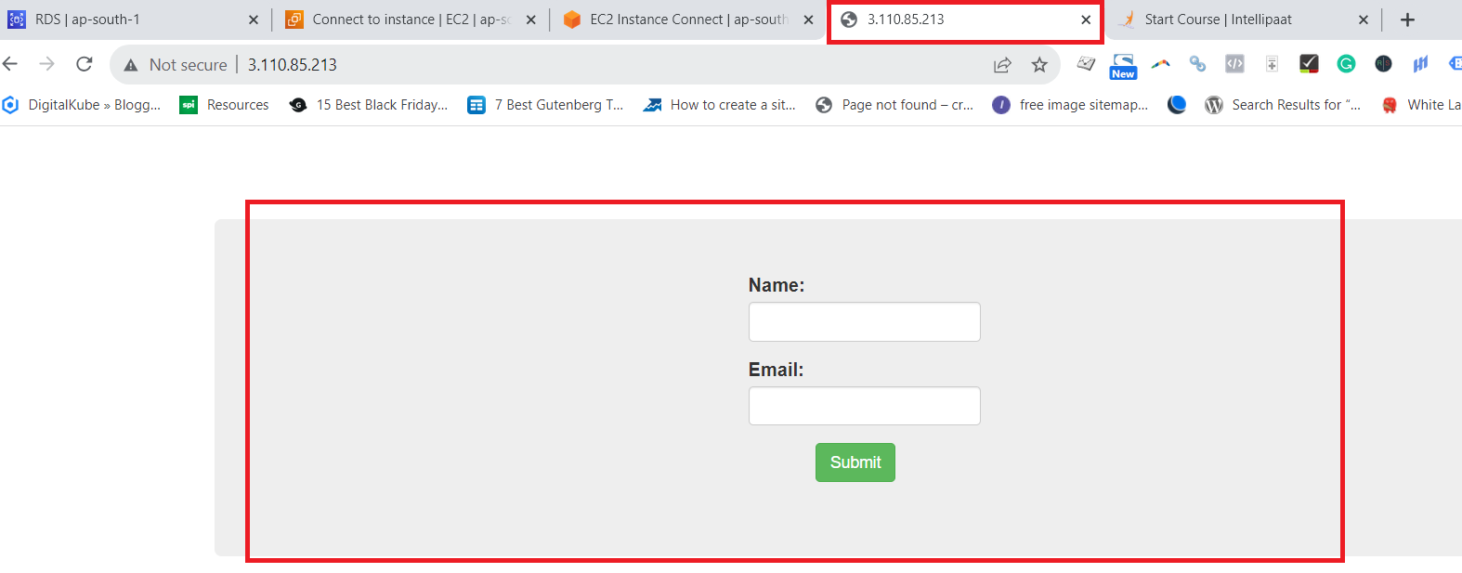

**D. Test the Database Connection with PHP Web Page Again**

**Step 1: Insert** the **“Name” and “Email” through** the **web page. Click** onthe **“Submit”** button.

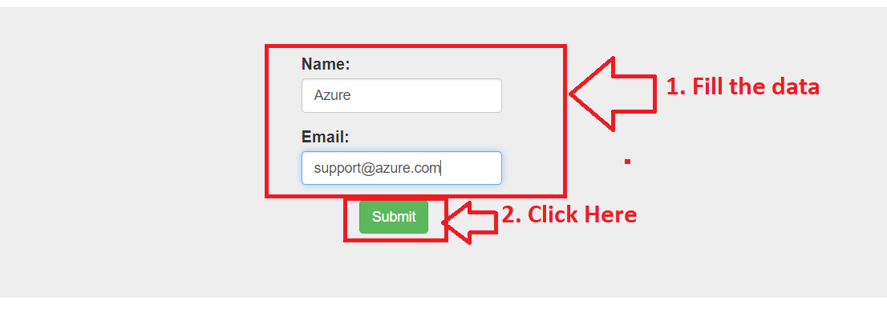

**Step 2: The record** will be **successfully created.**

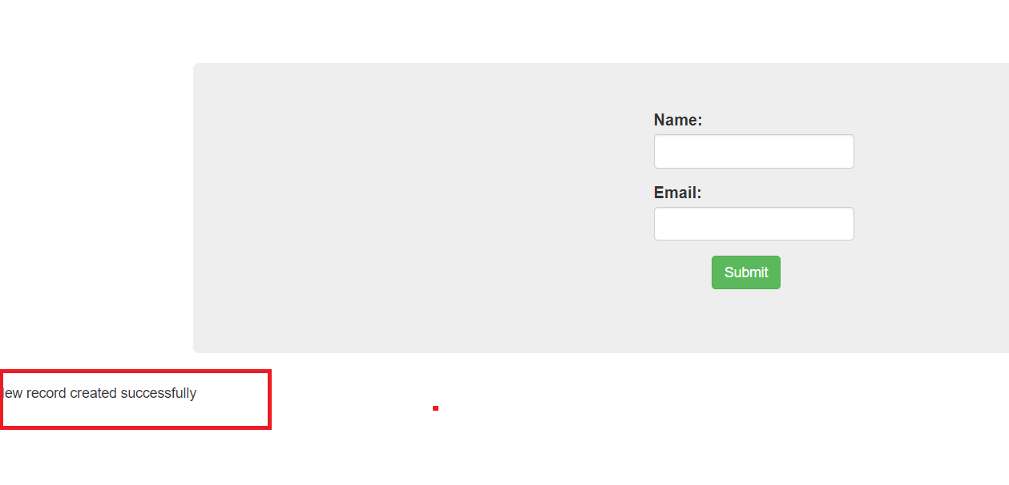

**Step 3: Go** to the **“EC2” Machine** & **connect machine** with **database using** the **following command: sudo mysql -h application-database.calupg2c7sxe.ap-south-1.rds.amazonaws.com -u admin -pintel123**

**The database** will be **successfully connected.**

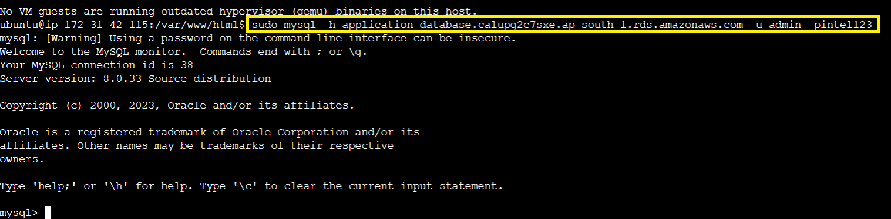

**Step 4: Now, go** to the **“intel” database. Write** the **command (“use intel;”)** here. **Now, we** will **inside** the **“intel” database.**



**Step 5: Type** the **“select * from data” query** & **you** will **notice** that **other record** will be **successfully inserted.**

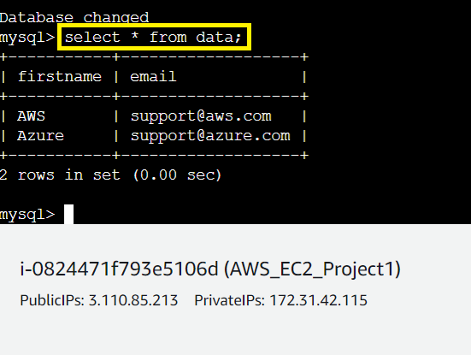

***So, our PHP website has been successfully configured with MySQL database.***

**4. Create the AMI (Amazon Machine Image) for Launch Template**

**Step 1: Go** tothe **“Services”** section & **search** the **“EC2”. Put cursor** over **“EC2”** & **click** onthe **“Instances”.**

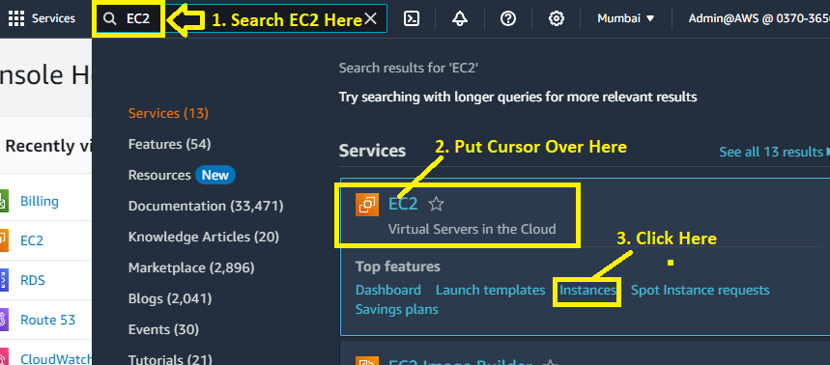

**Step 2: Select** the **Instance (“AWS_EC2_Project1”)** & **Go** to the **“Actions>Image and templates>Create image”.**

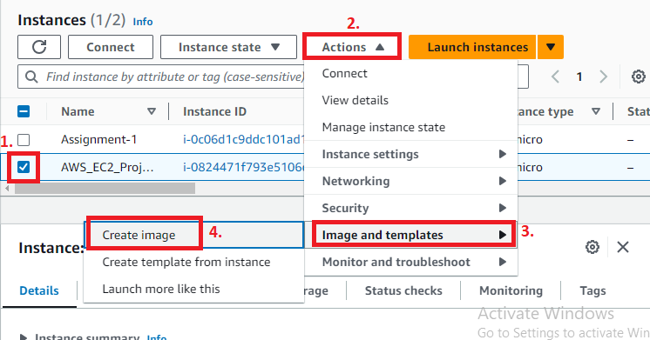

**Step 3: Write “Image Name & Description” as “AWS_EC2_Project1_Images”.**

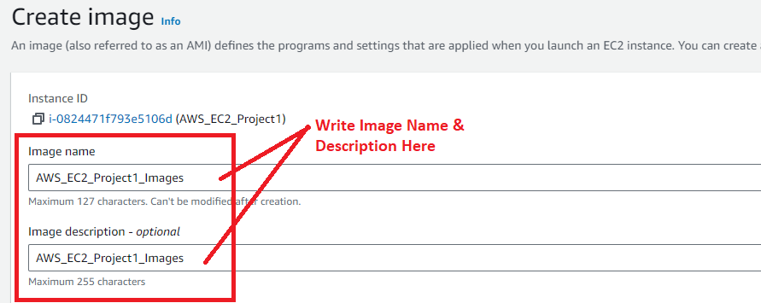

**Step 4: While, leave** the **other settings** as it **is. While** inthe **“Tags-optional”** section, **choose** the **“Tag image and snapshots together”. Click** onthe **“Create image”.**

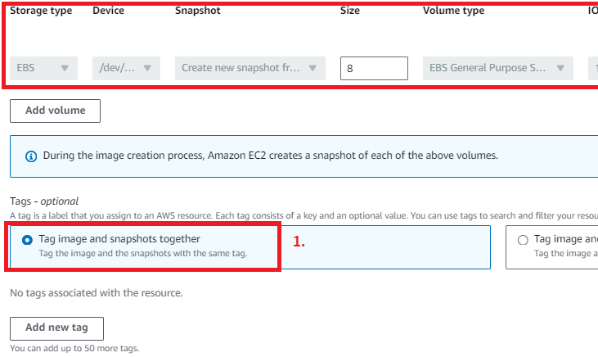

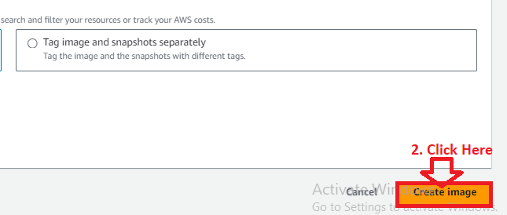

**Step 5: The “AMI”** will be **start creating. Click** on the **“Hyperlink”** in the **green strip.**

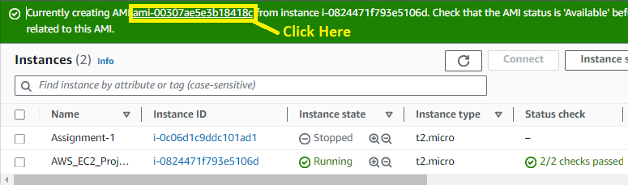

**Step 6: In starting, your “AMI Status”** will be **“Pending”. It** will **take some time (3-5 Minutes)** to **show** as **“Available”** status**.**

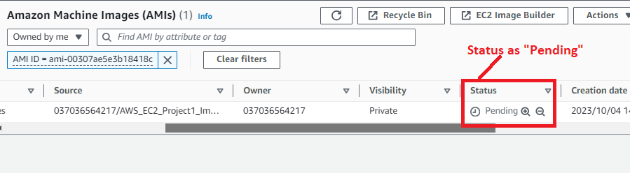

**Step 7: Now,** the **“AMI Status”** is **showing** inthe **“Available”** State.

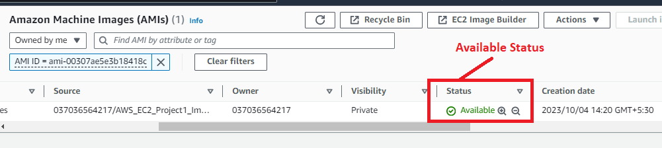

**Step 8: Scroll** tothe **left** & **click** onthe **“Edit Icon”.**

**Choose** your **“Name”** as **“AWS_EC2_Project1_AMI”.** While the **“Name”** is a **tag** for **“AMI”.**

The **“Name”** will be **reflect** after the **AMI ID** like this**: ami-00307ae5e3b18418c (AWS_EC2_Project1_AMI).**

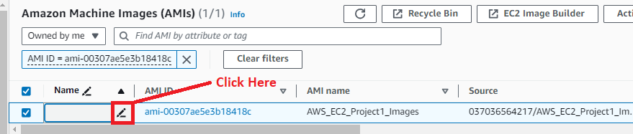

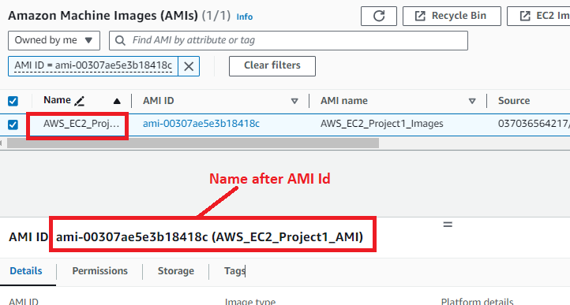

**5. Create the Launch Template for Auto Scaling Groups**

**Step 1: Go** tothe **“Launch Template”.**

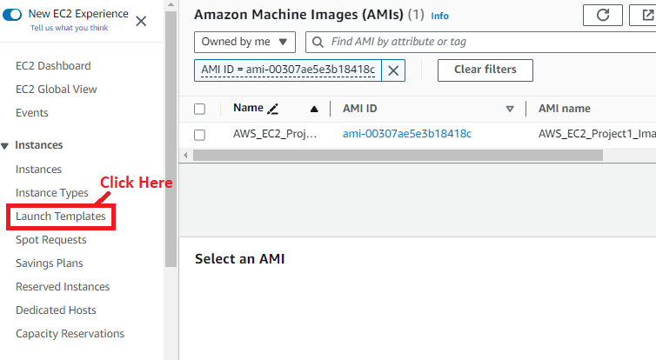

**Step 2: Click** onthe **“Create launch template”.**

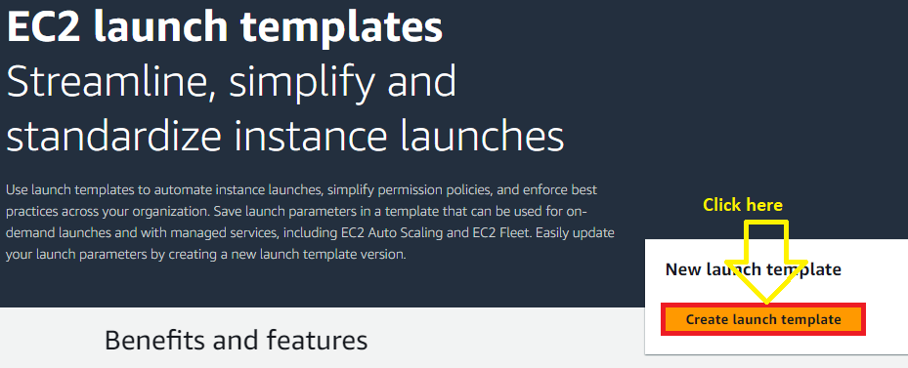

**Step 3: Fill** these **options** in the **“Launch template name and description”** inthe **“Create launch template”.**

**Launch template name -** AWS_EC2_Project_Template

**Template version description -** A launch template for EC2 Project

**Enable** the **option “Provide guidance to help me set up a template that I can use with EC2 Auto Scaling”** by **clicking** in the **“Auto Scaling guidance”** option.

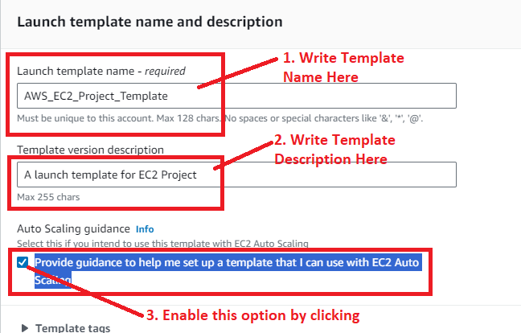

**Step 4: In** the **“Application and OS Images (Amazon Machine Image)- required”, choose** the **“My AMI” option. Select** your **created AMI here.**

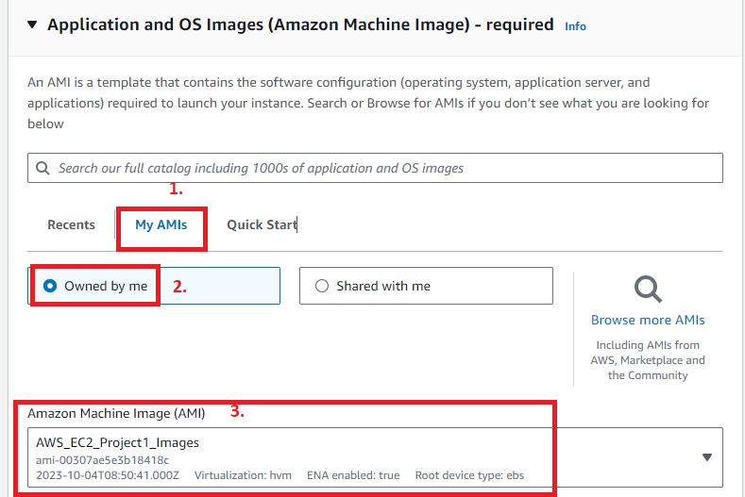

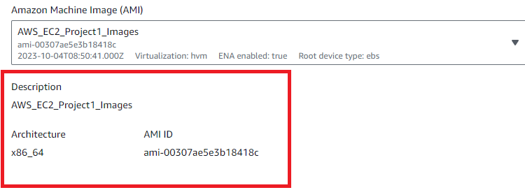

**Step 5: Choose** the **“instance type”** asthe **“t2.micro”, while key pair** asyours **key pair name “MY-WEB-SERVER”.**

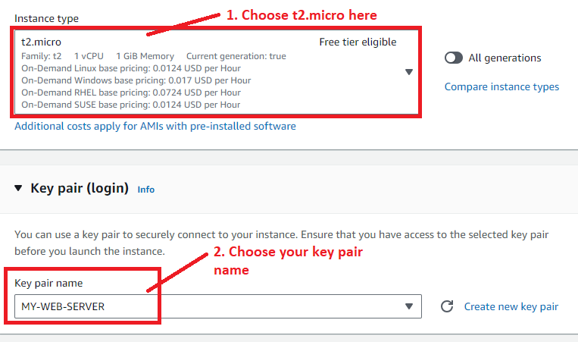

**Step 6: While leave the “Subnet”** as **it is. No need** to **choose here. While in** the **“Firewall (security groups)”, choose** the **“Select existing security group”. While choose** your **created security group (AWS_EC2_Project1)** herefor this **project.**

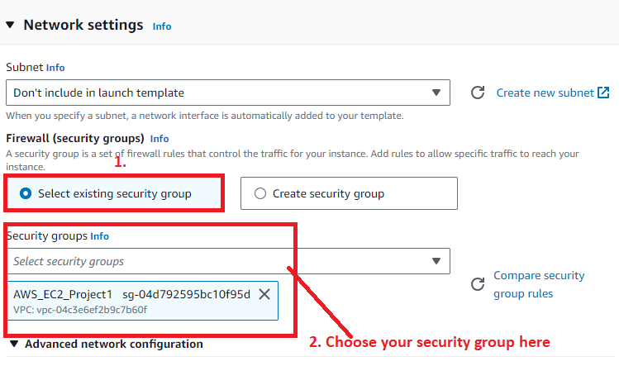

**Step 7: Click** onthe **“Create launch template”.**

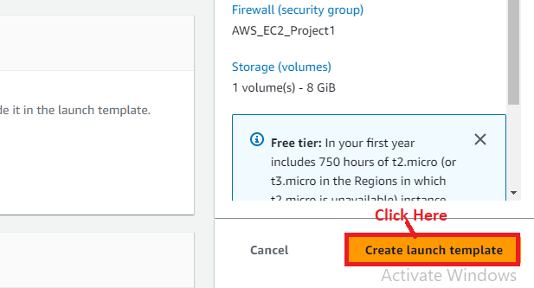

**Step 8: Your launch template (AWS_EC2_Project_Template(lt-0798f90e53f8c8c27)** will be **successfully created. Click** on the **hyperlink.**

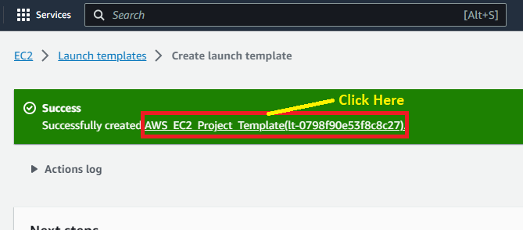

**Your launch template description** will be **shown after clicking** on the **hyperlink.**

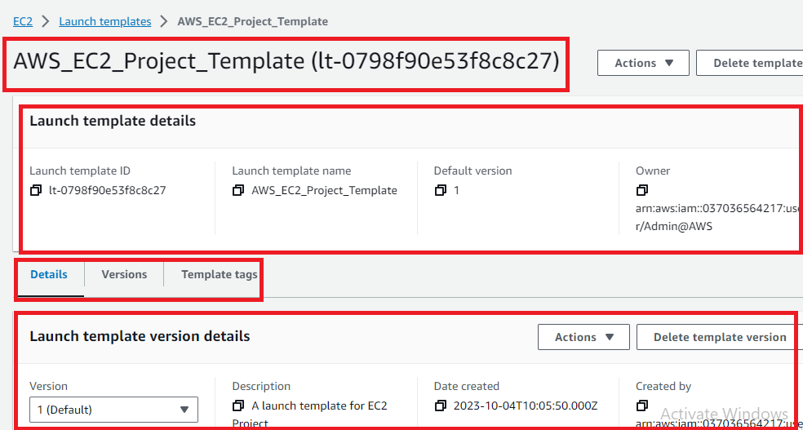

**6. Create an Auto Scaling Group for this PHP website**

**Step 1: Go** tothe **left side** & **click** onthe **“Auto Scaling Groups”** inthe **“Auto Scaling”.**

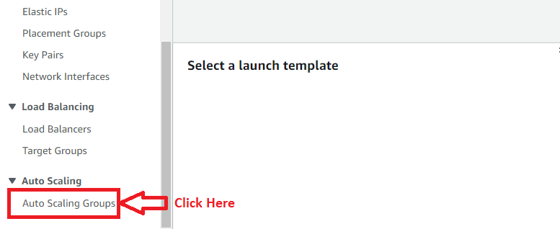

**Step 2: Click** onthe **“Create Auto Scaling group”.**

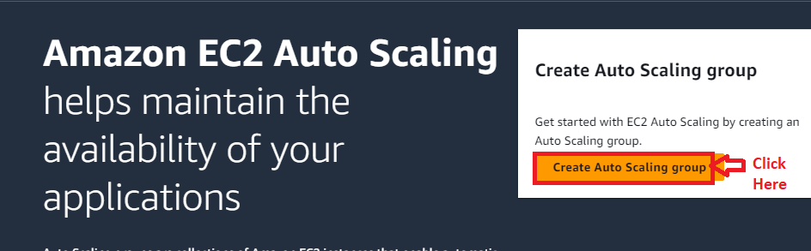

**Step 3: Choose** the **“Auto Scaling group name”** as **“AWS_EC2_Project1_ASG”.**

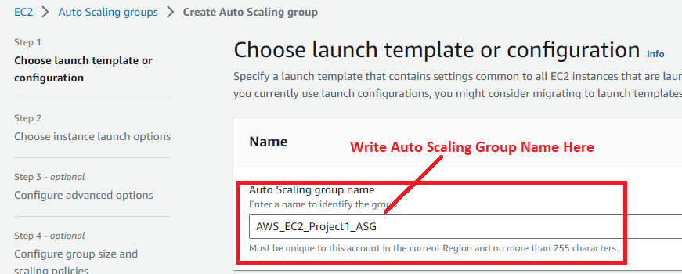

**Step 4: Choose** the **“Launch Template”** as **“AWS_EC2_Project_Template”. All** the **“launch template” configuration** will be **automatically fetched.**

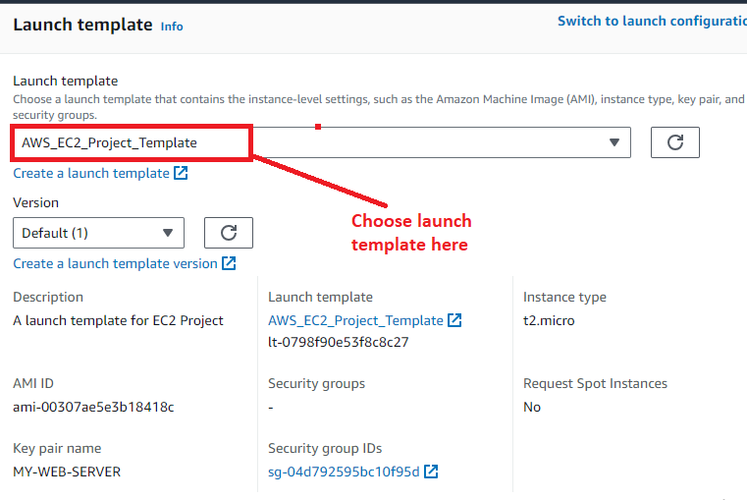

**Step 5: Click** on **“Next”.**

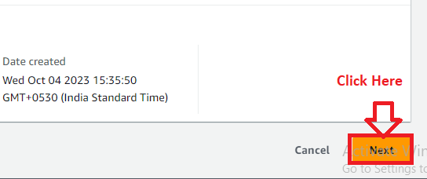

**Step 6: In** the **“Choose instance launch options”, the “Launch template” features** will be **shown** in **“Instance type requirements”.**

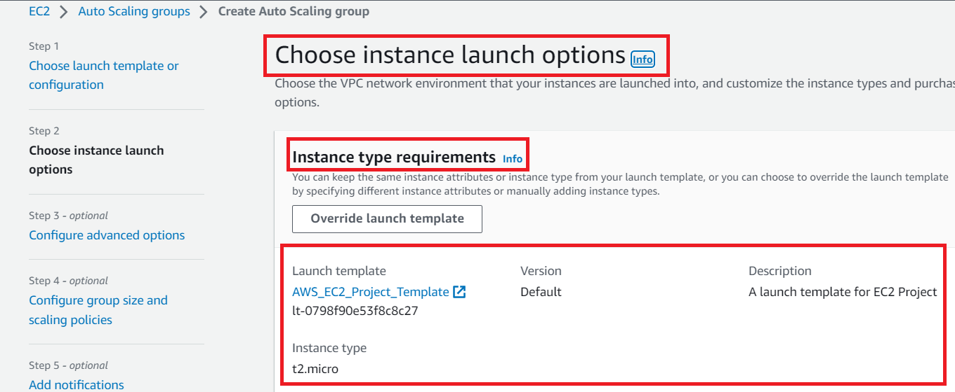

**Step 7: In** the **“Networks”, leave** the **“VPC” settings** as **it is. While** inthe **“Availability zones and subnets”, choose** the **“ap-south-1a zone** withthe **default subnet”** &the **“ap-south-1b” zone** with **created subnet (Zone_B)”.**

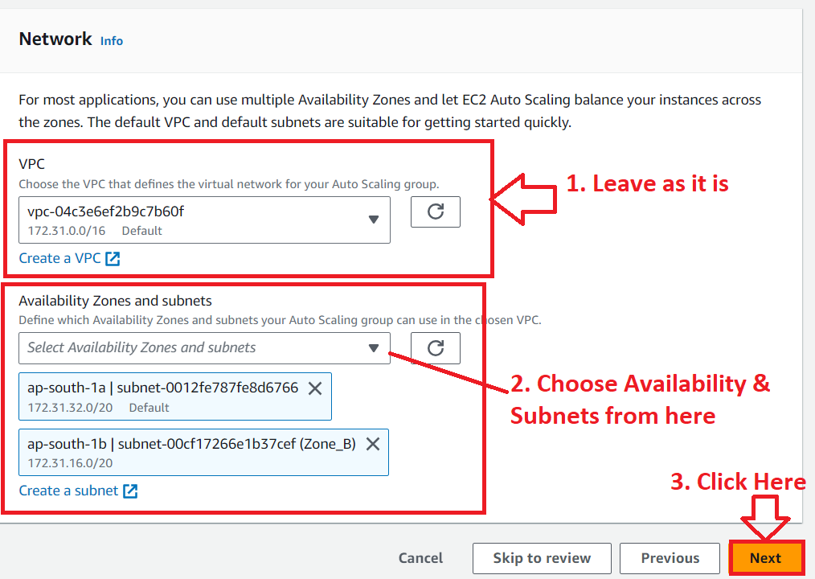

**Click** onthe **“Next”.**

**Step 8: Choose** the **“No load balancer”** optionin **“Load balancing” option. Click** onthe **“Next”.**

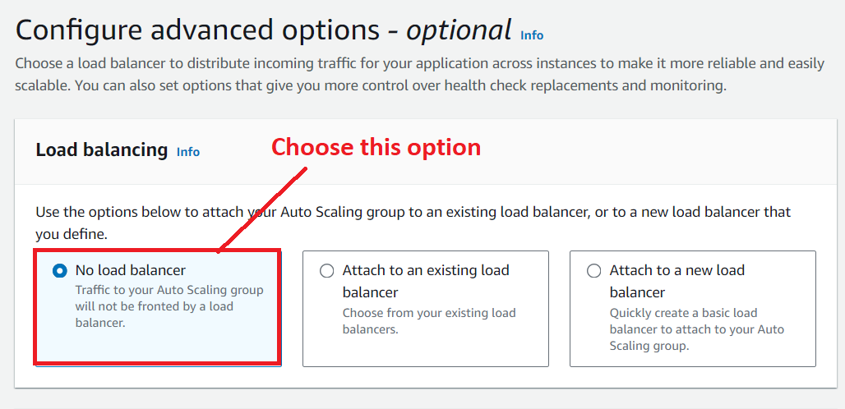

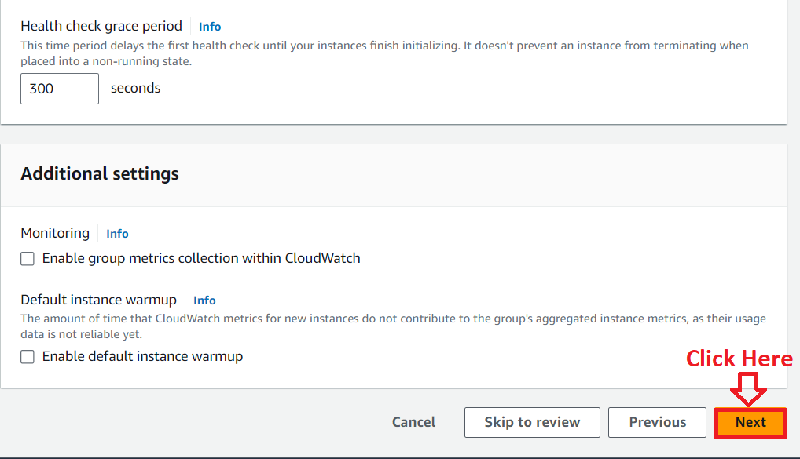

**Step 9: In** the **“group size” choose** the **following metrics:**

**Desired capacity – 2**

**Minimum capacity – 1**

**Maximum capacity – 3**

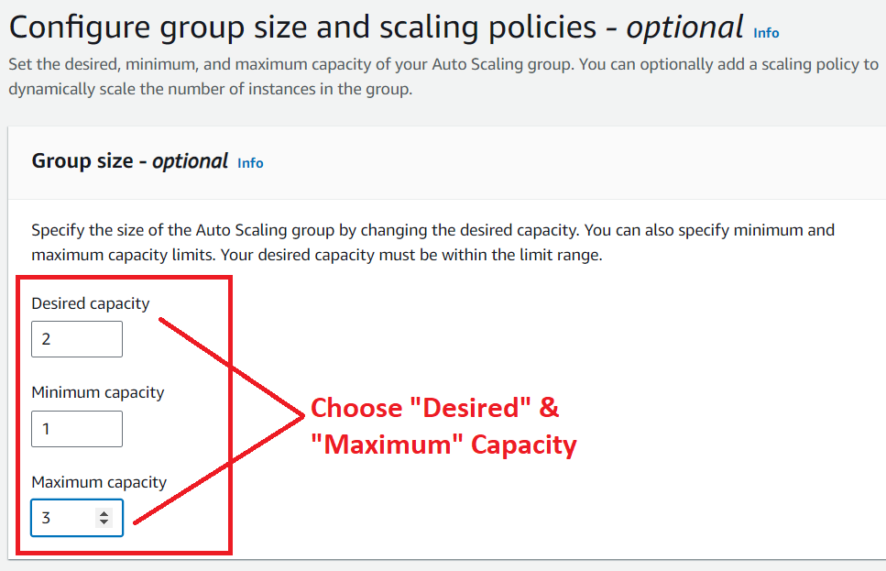

**Step 10: Choose** the **“Scaling policies – optional”** as **“None”. Click** onthe **“Next”.**

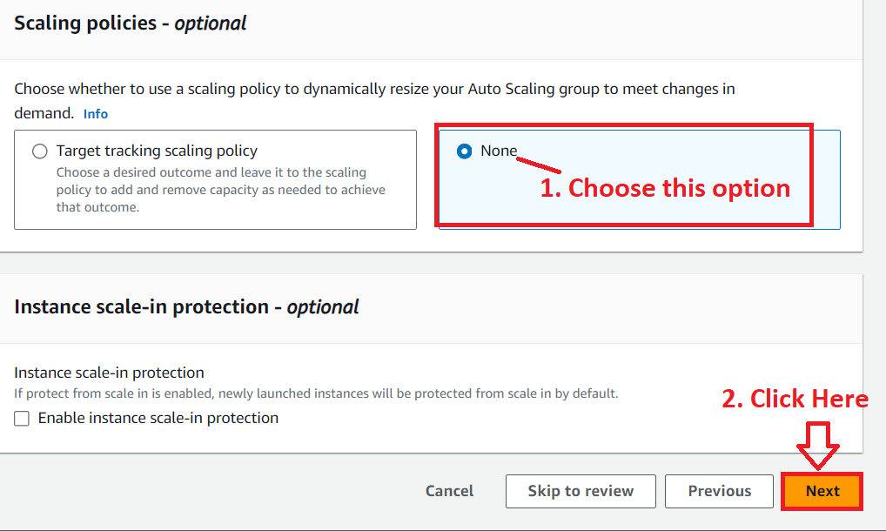

**Step 11: Click** on the **“Next”** in the **“Add notifications-optional”.**

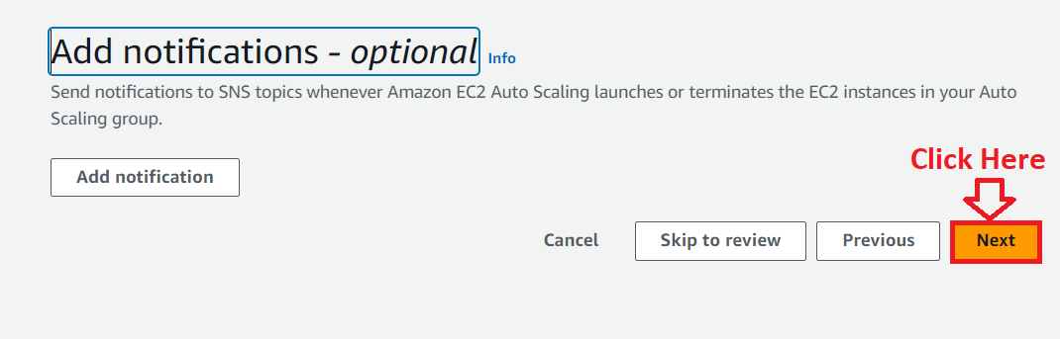

**Step 12: Click** on the **“Add tag”.**

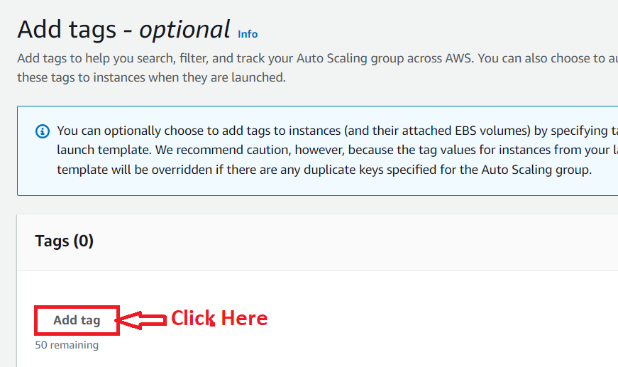

**Step 13: Choose** the **following options** here:

**Key – Name**

**Value-optional: - asg-autoscaling-grp**

**Tag new instances – Remain enable**

**Click** on **“Next”.**

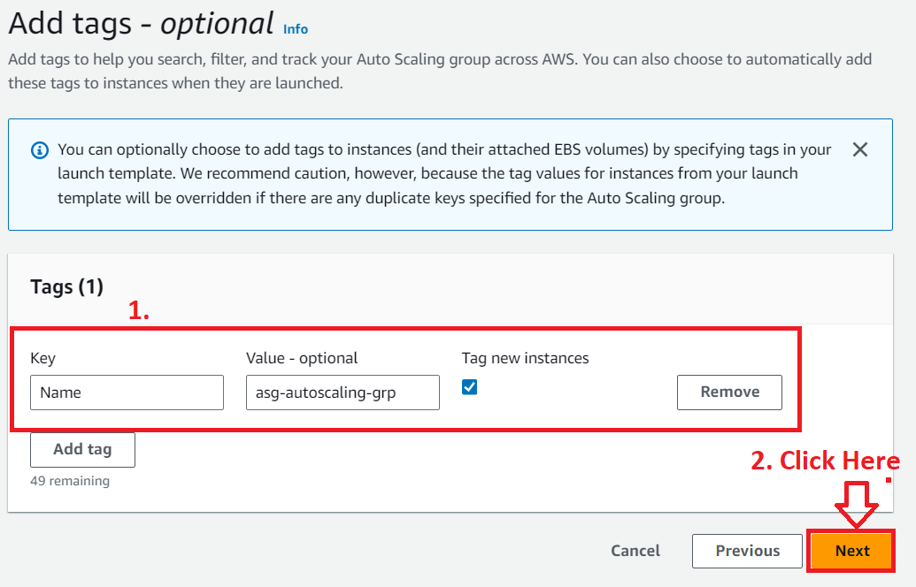

**Step 14: In** the **“Review”** section, **scroll down** and **click** onthe **“Create auto scaling group”.**

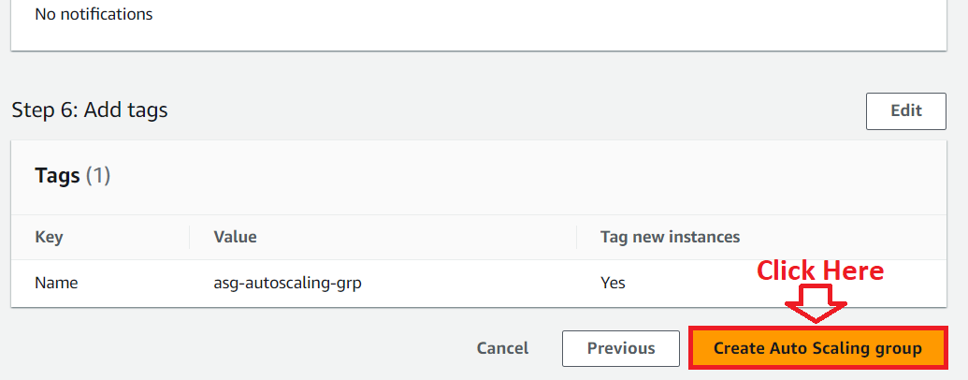

**Step 15: Your “Auto Scaling Group”** will be **created successfully. Click** onthe **“AWS_EC2_Project1_ASG”.**

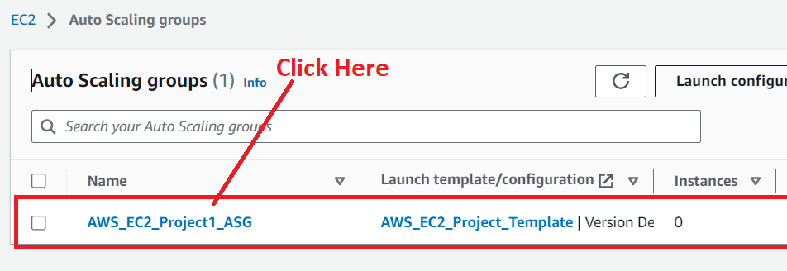

**Step 16: Your “Auto Scaling Group” details** will be **shown here** & **go to** the **“Activity”** section.

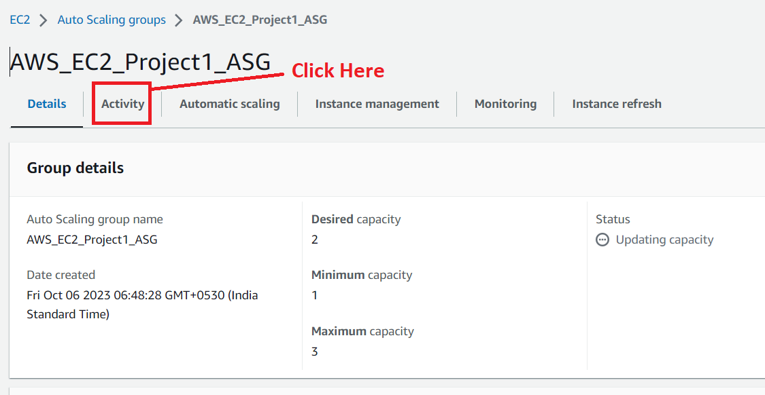

**Step 17:** The **“EC2 Auto Scaling Group”** will be **successfully launched** your **instances.**

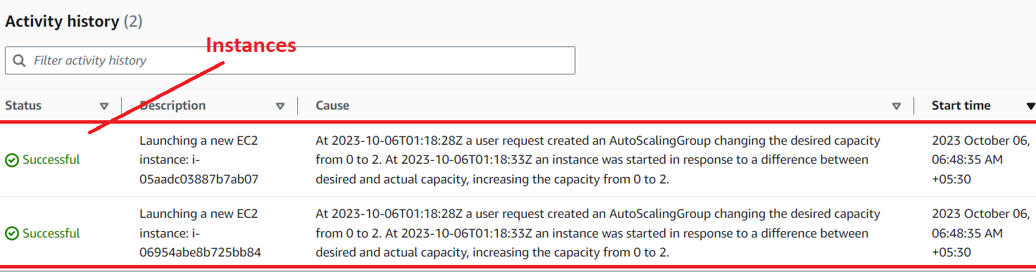

**Step 18: Click** on the **“EC2”.**

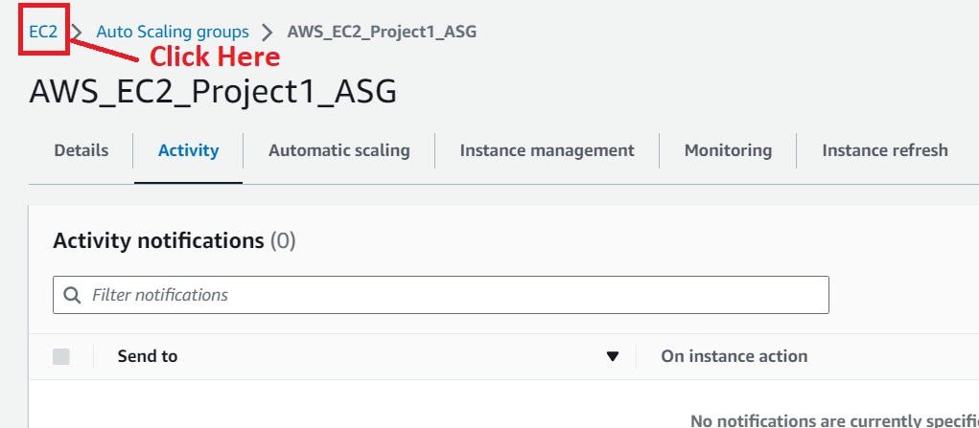

**Step 19: Go** to the **“Instances (running)”.**

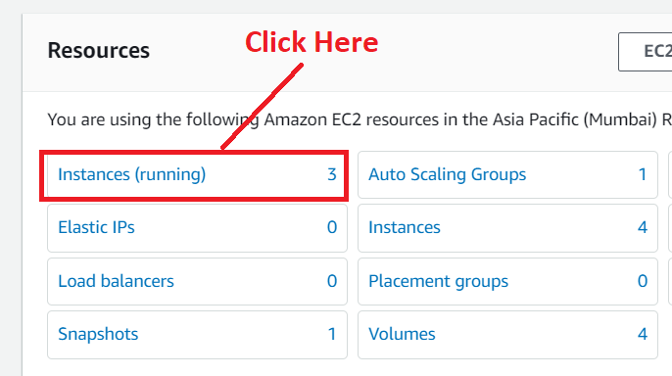

**Step 20: You** will **notice** that **your Auto Scaling Group Instances** are **successfully running.**

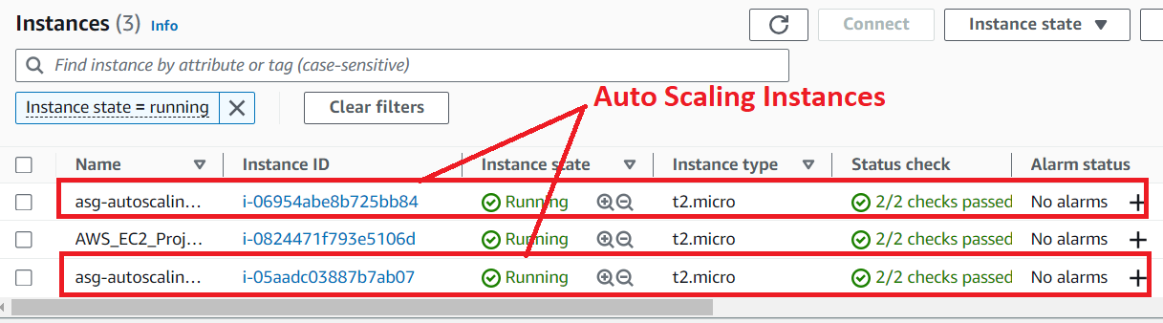

**7. Create a Target Group for Load Balancer**

**Step 1: In** the **left side, scroll down. Click** onthe **“Target Groups”** inthe **“Load Balancing”.**

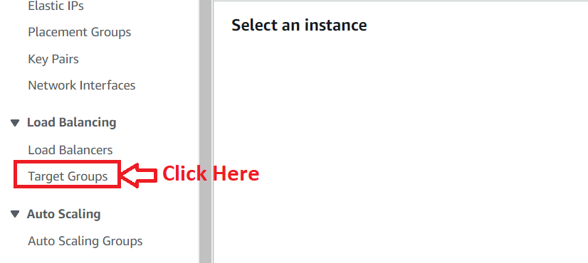

**Step 2: Click** on the **“Create target group”.**

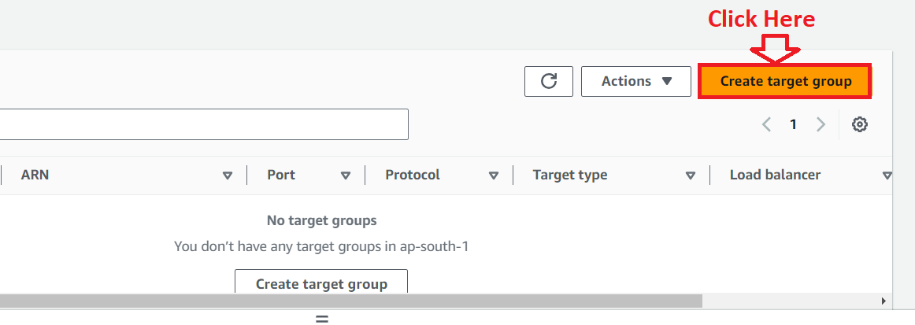

**Step 3: Choose** the **“instances”** as **“Choose a target type”.**

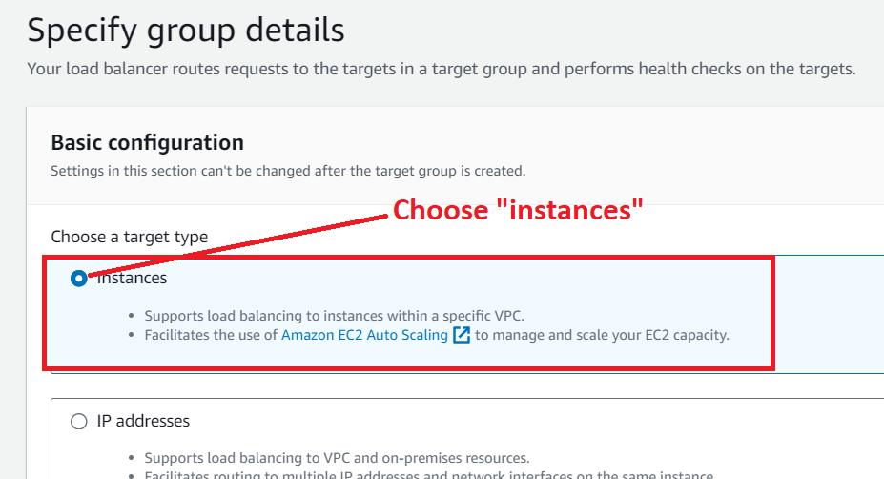

**Step 4: Choose** the **“Target Group Name”** asthe **“EC2-Project-Target-Group”. Leave** the **other settings** as **by default.**

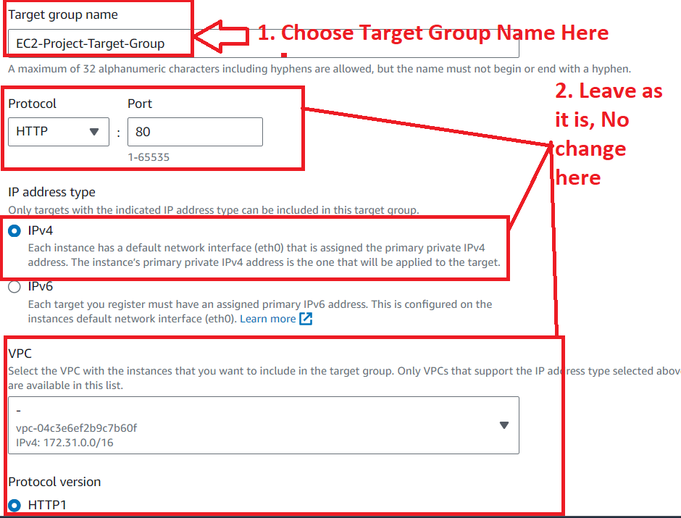

**Step 5: Click** onthe **“Next”.**

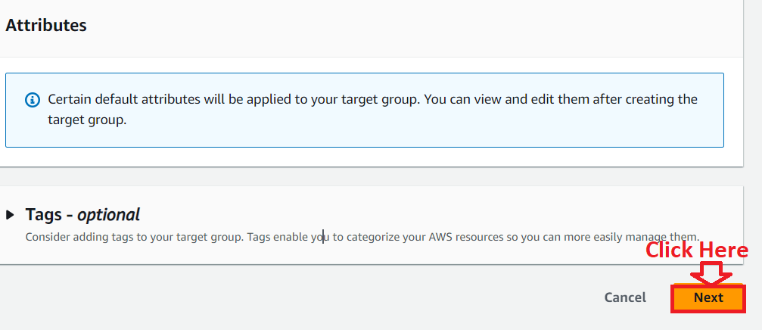

**Step 6: Choose** the **third instance (AWS_EC2_Project1)** as an **“Available Instance”, because others** are **“Auto Scaling Groups” instances, you can delete those** & **they will come again** as **it is. While “AWS_EC2_Project1”** is the **main instance. From which we do** the **traffic flow** to **other instances.**

**Click** onthe **“Include as pending below”.**

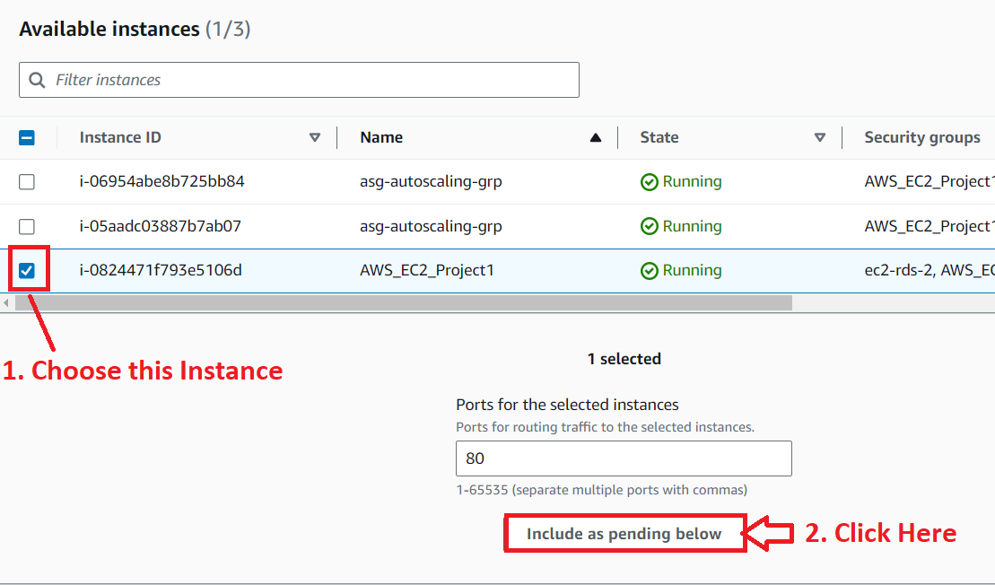

**Step 7: In** the **“Review targets”, your instance** will be **added. Click** onthe **“Create target group”.**

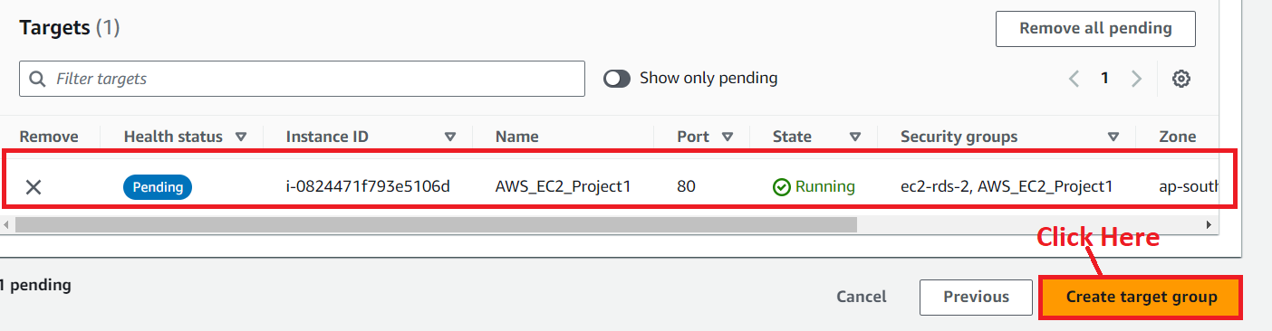

**Step 8: Your target group (EC2-Project-Target-Group)** will be **successfully created.**

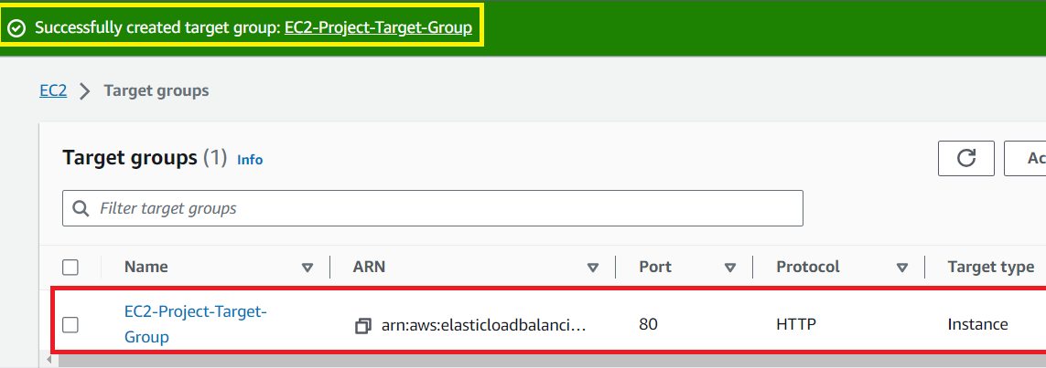

**Step 9: Click** on the **“EC2-Project_Target-Group”. You** will **notice** that **“One Healthy” target** has been **registered.**

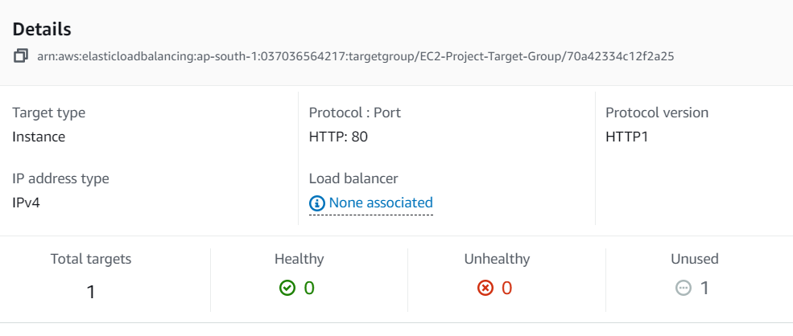

***In the “Load Balancer” section, you will notice that “None associated”, now we will create a load balancer. Which will receive the traffic & send the request to the targets one by one. If target is unhealthy, load balancer will not send the traffic.***

**8. Create a Load Balancer for Balancing the Traffic**

**Step 1: Go** tothe **left side** & **click** on the **“Load Balancers”** inthe **“Load Balancing”** option.

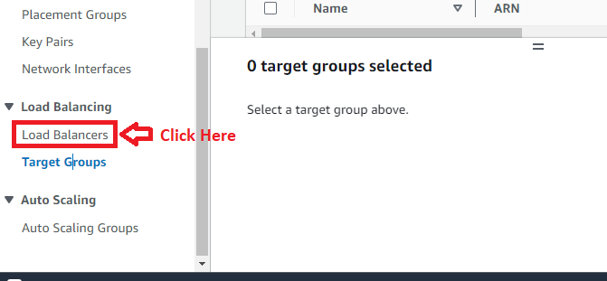

**Step 2: Click** onthe **“Create load balancer”.**

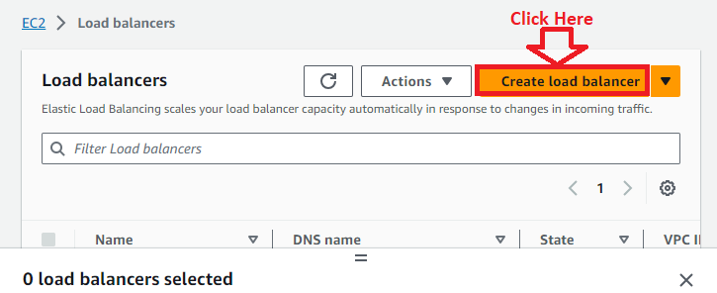

**Step 3: Go** to the **“Application Load Balancer”** & **click** onthe **“Create”.**

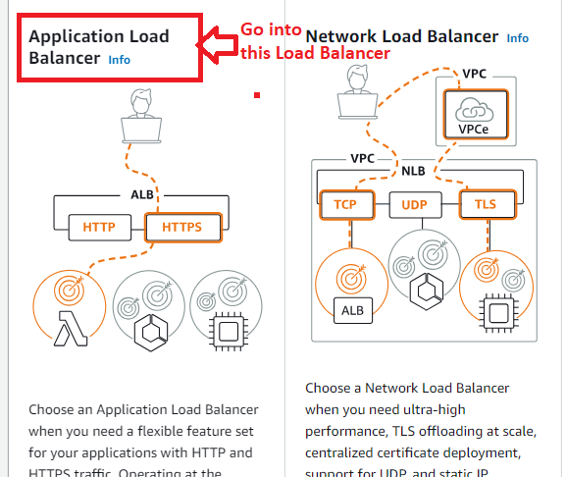

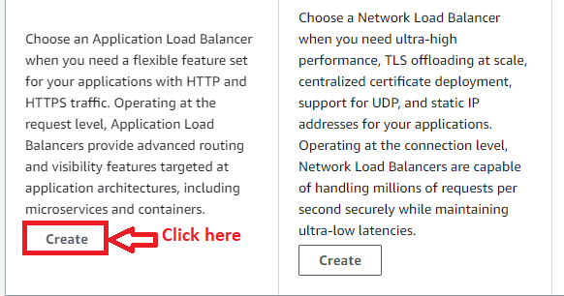

**Step 4: In** the **“Basic Configuration”, choose** the **“Load balancer name”** asthe **“AWS-EC2-Project-Load-Balancer”. While** leave the **“scheme address”** as the **“Internet-facing”** &the **“IP address type”** as **“IPv4”.**

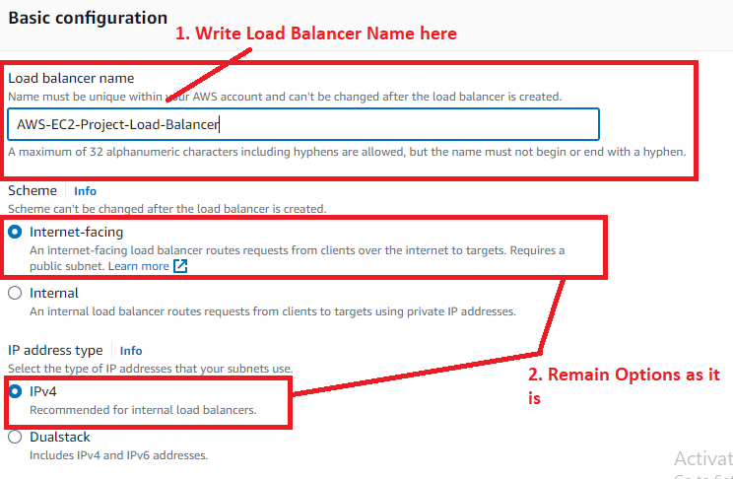

**Step 5: In** the **“Network Mapping”, choose** the **“ap-south-1a” & “ap-soth-1b” zones** with its **subnets.**

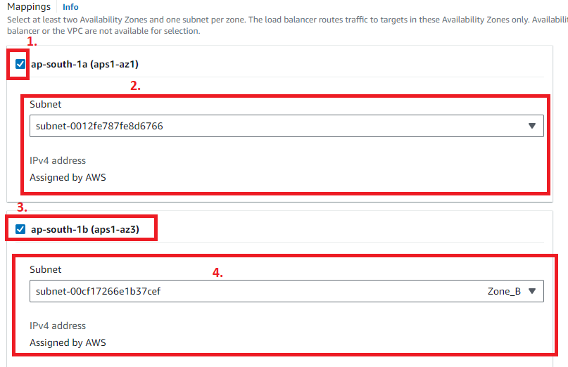

**Step 6: Choose** the **“Security groups”** as **created** in the **beginning** of **EC2 Creation. We** have **created** the **“AWS_EC2_Project1”** & **choose** this **security group** here**.**

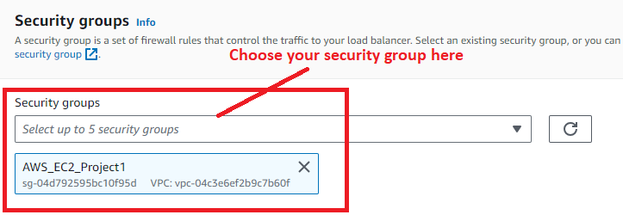

**Step 7: In “Listeners and routing”, choose** your **“Target Group (EC2-Project-Target Group)”.**

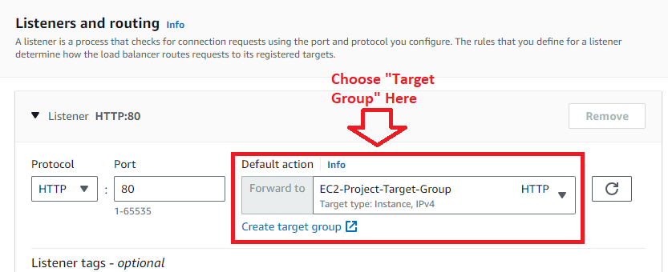

**Step 8: Leave other settings** as it is**. Click** on **“Create load balancer”.**

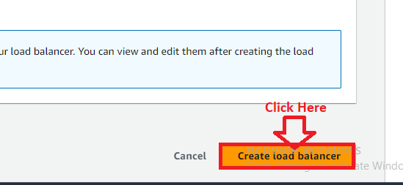

**Step 9: Your load balancer** will be **successfully created. Click** on the **“Hyperlink”** to **view** the **load balancer details.**

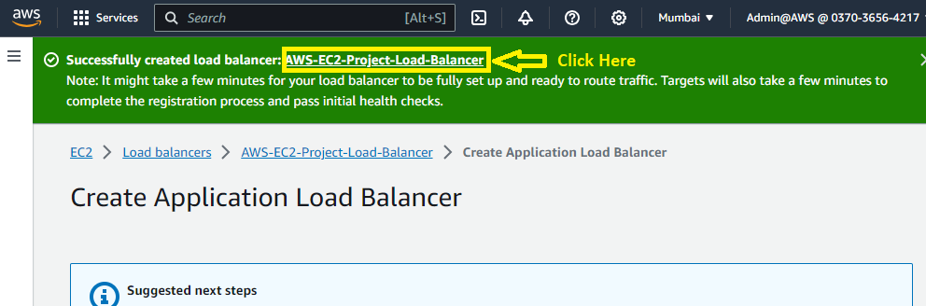

**Step 10: You** will **notice** that **“Load Balancer”** will be **successfully created & in “Active” state.**

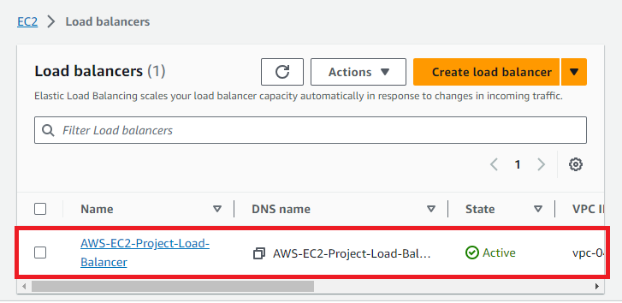

**9. Attach the Load Balancer to Auto Scaling Group**

**Step 1: Go** tothe **left side** & **click** onthe **“Auto Scaling Groups”** inthe **“Auto Scaling”.**

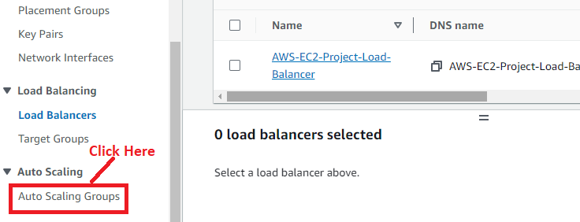

**Step 2: Click** on the **“AWS_EC2_Project1_ASG”.**

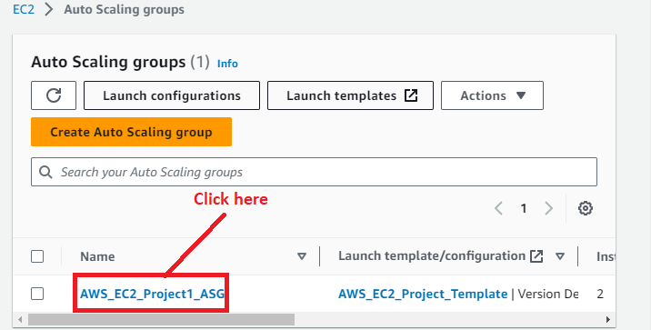

**Step 3: Go** to the **“Details”** section& **scroll down.**

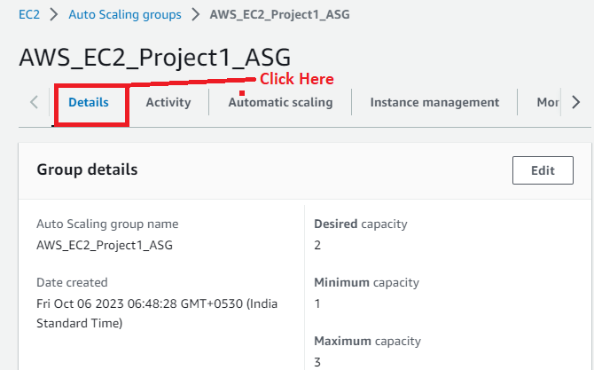

**Step 4: In** the **“Load balancing”, click** on the **“Edit”.**

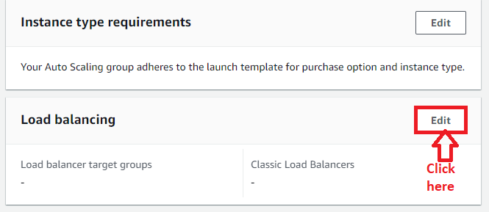

**Step 5: Choose** the **“Application, Network or Gateway Load Balancer target groups”** option& **select** your **target group (EC2-Project-Target_Group)** here**.**

**Click** onthe **“Update”.**

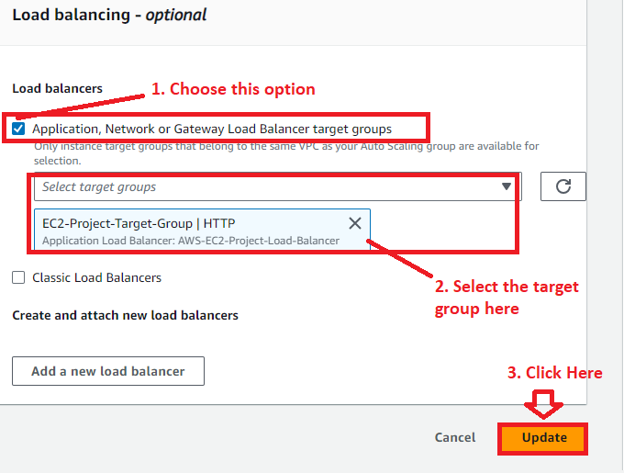

**Step 6: Your load balancer** will be **successfully attached.**

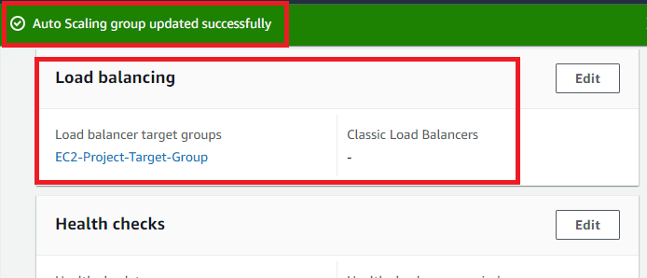

**10. Test the Load Balancer Will Working Fine or Not**

**Step 1: Go** tothe **left side** & **click** onthe **“Load Balancers”** inthe **“Load Balancing”** option.



**Step 2: Click** on the **“Name (AWS-EC2-Project-Load-Balancer)”.**

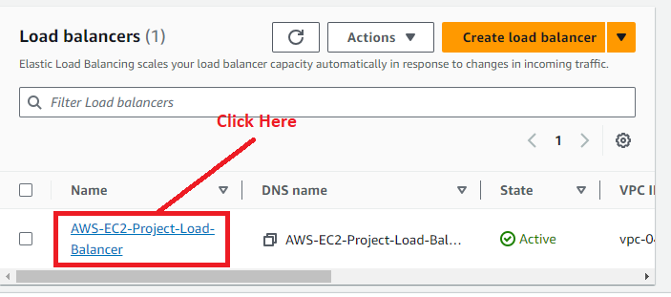

**Step 3: Copy** the **“DNS Name (AWS-EC2-Project-Load-Balancer-1657334538.ap-south-1.elb.amazonaws.com)”.**

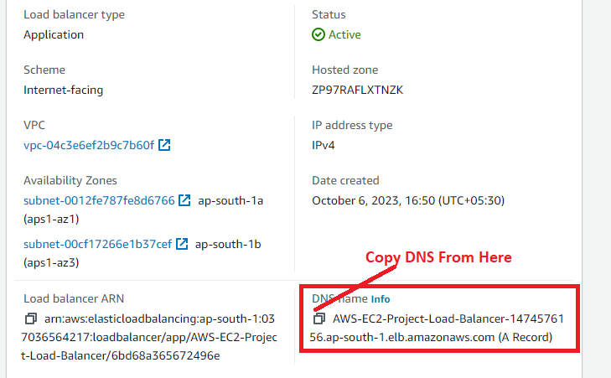

**Step 4: Paste** the **“DNS Name”** into the **“Browser Address Bar”. When** you **refresh** your **DNS multiple times, same page** will **have shown here.**

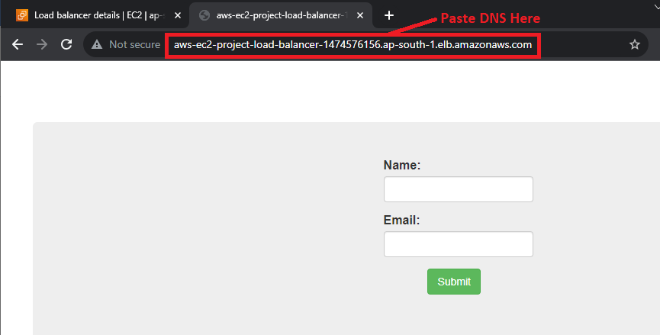

***This means the load balancer is working fine.***

**11. Route Traffic from Load Balancer to A Specific Domain (Optional)**

**Step 1: Go** to the **“Services”** section& **search** the **“Route 53”. Click** onthe **“Hosted Zones”.**

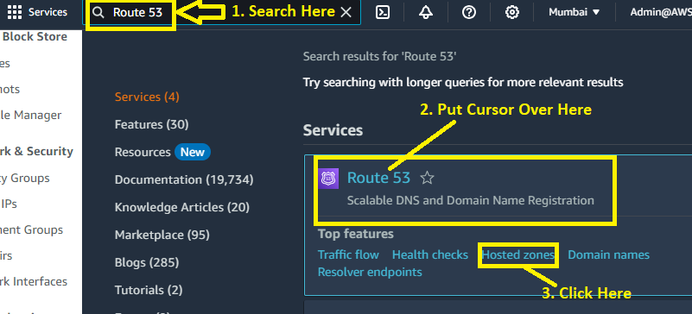

**Step 2: *We have*** *a* ***domain (visal.click)*** *with the* ***hosted zones.***

**Click** onthe **“visal.click”** under **Hosted zone name.**

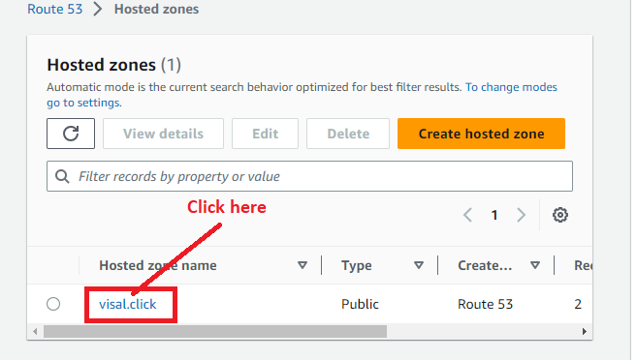

**Step 3: Click** onthe **“Create record”.**

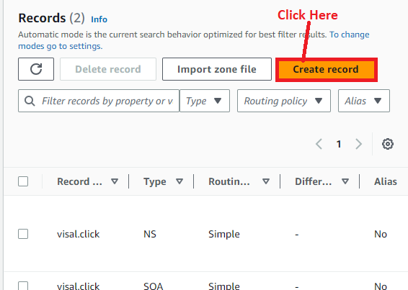

**Step 4: Enable** the **“Alias” option. Choose** the **following options here:**

**Choose endpoint: -** Alias to Application and Classic Load Balancer

**Choose Region: -** Asia Pacific (Mumbai)

**Choose load balancer: -** dualstack.AWS-EC2-Project-Load-Balancer-1474576156.ap-south-1.elb.amazonaws.com

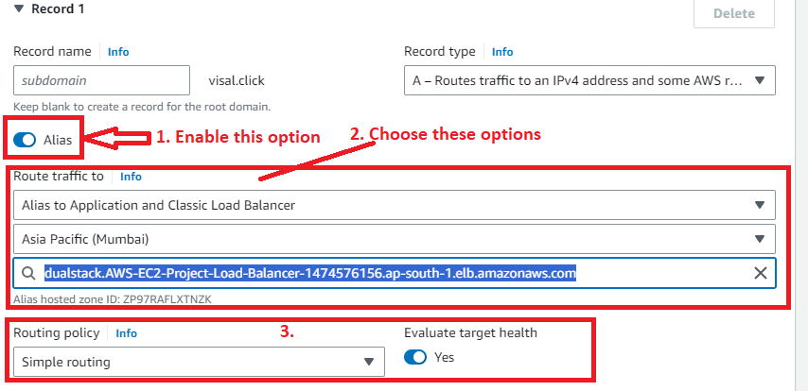

**Routing policy –** Simple routing

**Click** on the **“Create records”.**

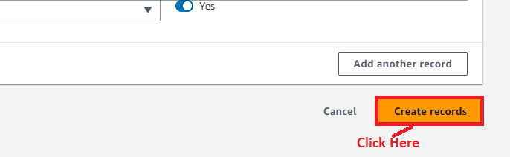

**Step 5: The record** will be **successfully created. Click** onthe **“View status”. It** will **take 60 seconds** to be **active.**

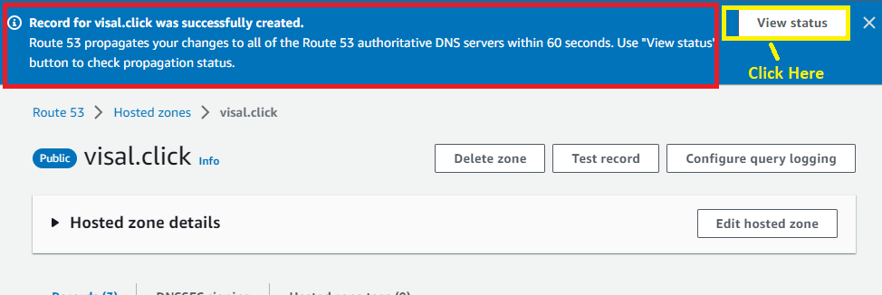

**Step 6: First, it** will be **in** the **“Pending State”.**

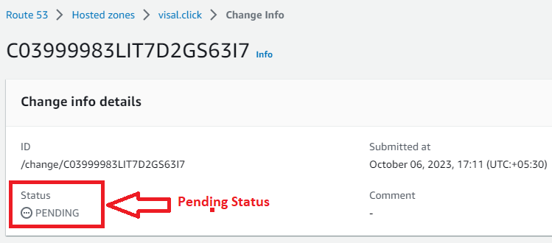

**Step 7: After** the **60 seconds, it** will **show** in the **“INSYNC” mode. This means,** your **records** will be **successfully created** & the **load balancer traffic** will be **successfully routed** tothe **domain name.**

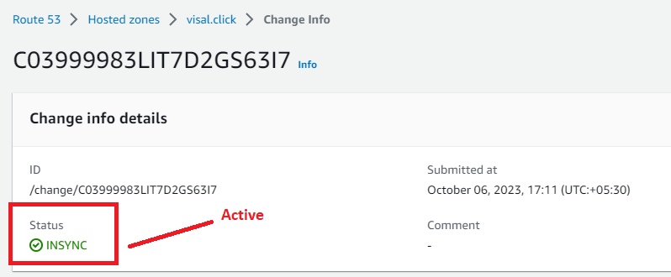

**Step 8: Type** the **domain** in **the separate browser address bar. You** will **notice** that **same PHP website** will be **visible** on **the registered domain (visal.click).**

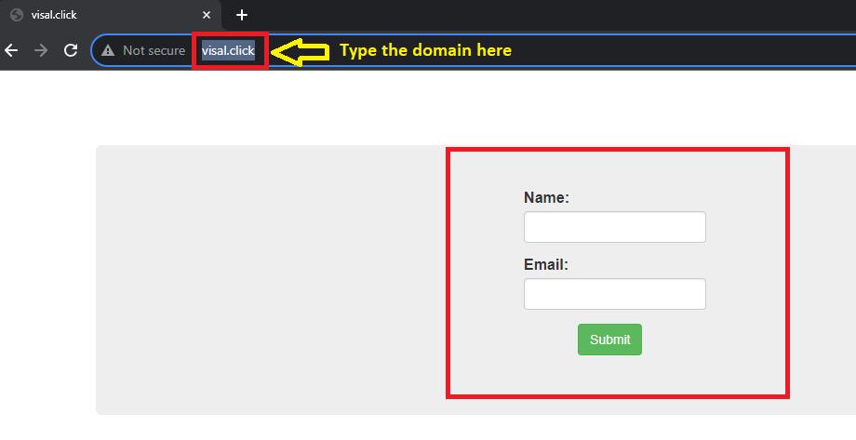

**12. Test the Auto Scaling is Working Properly or Not**

**Now, we** will **test** that **auto scaling group** is **working fine or not. We** will **delete** the **auto scaling groups** & **test that website** is **working properly** or **not.**

**Step 1: Go** tothe **“Services”** section& **search** the **“EC2”. Put cursor** over the **“EC2”** & **click** on the **“Instances.**

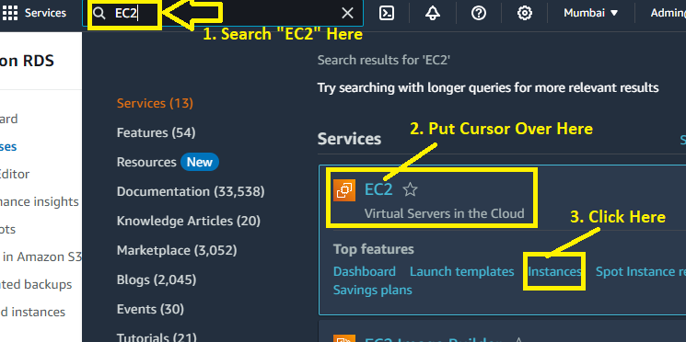

**Step 2: We** will **select both** the **“asg-autoscaling-grp” Instances** & **click** on the **“Instance State”. Terminate** the **instance** by **clicking** onthe **Terminate instance.**

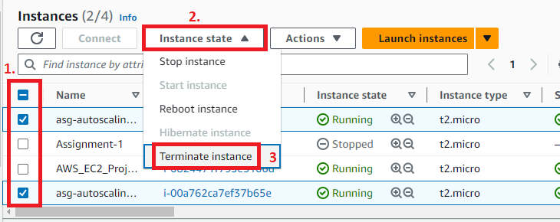

**Step 3: Click** onthe **“Terminate”.**

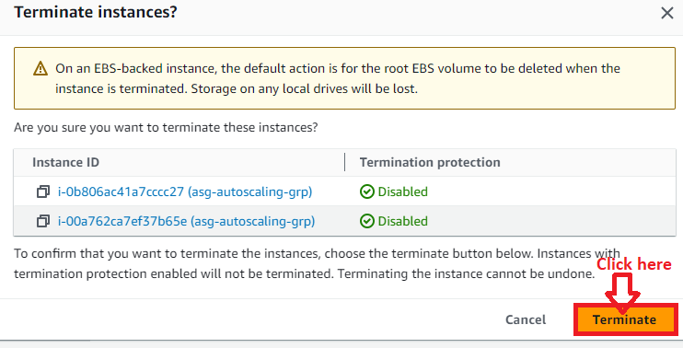

**Step 4: Your instance** will be **successfully terminated.**

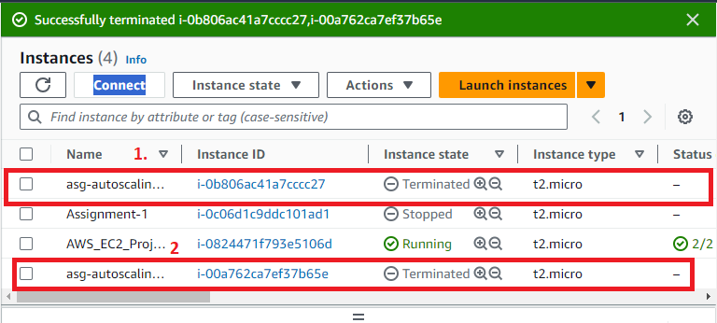

**Step 5: When we wait** for **some time** & **refresh** the **instances. You** will **notice** thatthe **two new instances (asg-autoscaling-grp)** is **successfully created** &in the **“Running” state.**

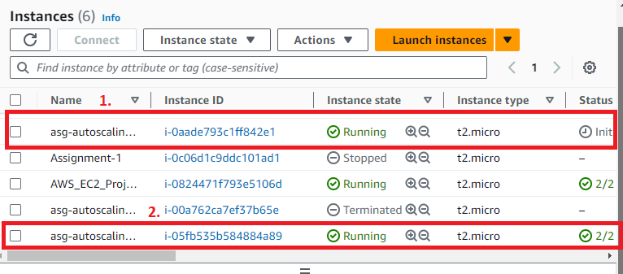

**Step 6: Go** to the **left side** & **click** onthe **“Auto Scaling Groups”** in the **“Auto Scaling”.**

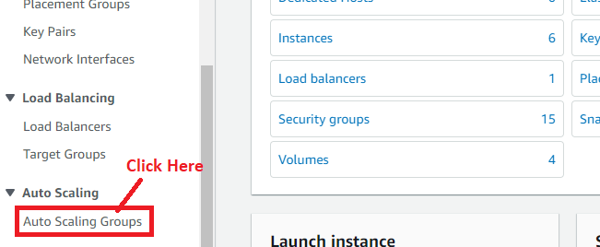

**Step 7: Click** on the **“AWS_EC2_Project1_ASG”.**

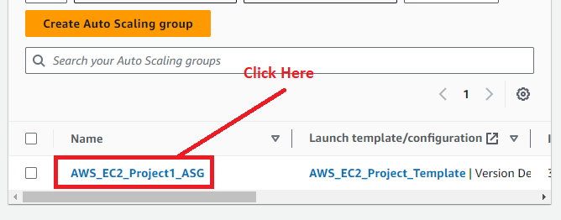

**Step 8: Go** tothe **“Activity”** & **you** will **notice** that **instance** has been **successfully terminated** & **again created.**

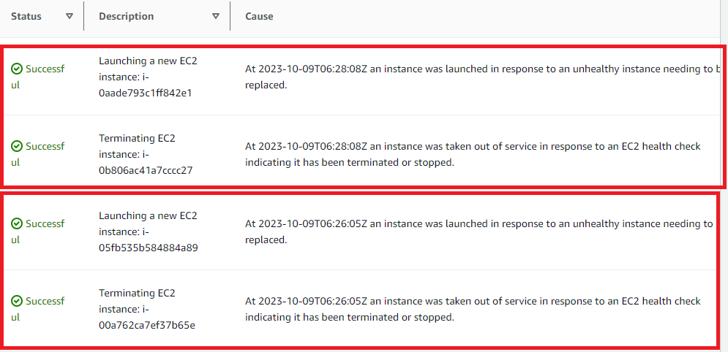

**Step 9: When we refresh** our **domain (visal.click), it** is **showing** that **our PHP website is up** & **running. No downtime for us here.**



**13. Test the Database is Working Properly or Not**

We have checked that our website is working fine with EC2 Server, Elastic Load Balancer & Auto Scaling Groups. No problem in page loading & routing to domain.

Now, we will test our database is successfully storing the data or not.

**Step 1: We will fill the following entries in the name:**

**Name – Google**

**Email –** [**support@google.com**](mailto:support@google.com)

**Click** on the **“Submit”.**

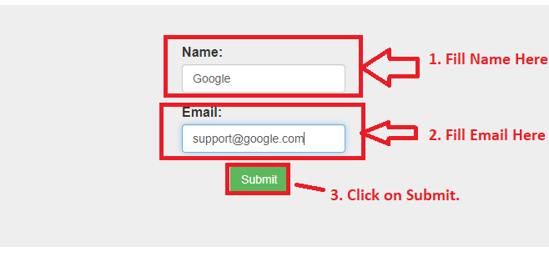

**Step 2: A** message **“New record created successfully”** has been **shown** after **submitting** the **details.**

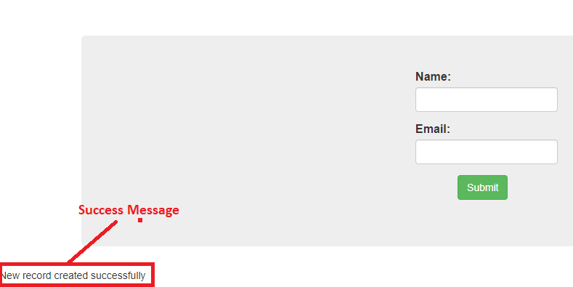

**Step 3: Now, we** will **go** to our **EC2 instance (AWS_EC2_Project1), where we** have **created** the **website. Now, we** will **connect** the **website** to the **database again** & **check that information** in the **database is showing** or **not.**

**Go** to the **“EC2” Machine** & **connect** the **machine** with the **database using** the **following command: sudo mysql -h application-database.calupg2c7sxe.ap-south-1.rds.amazonaws.com -u admin -pintel123**

**The database** will be **successfully connected.**



**Step 4: Now, go** to the **“intel” database. Write** the **command (“use intel”) here. Now, we** are **inside** the **“intel” database.**



**Step 5: When we run the “select * from data;” command, it is showing our filled data.**

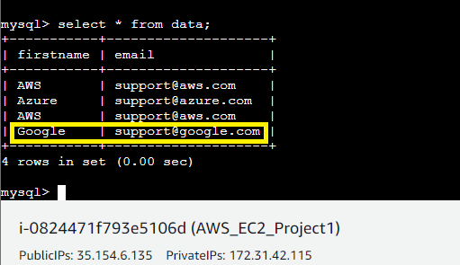

***This means, our website & database is successfully connecting and working fine with Auto Scaling Groups.***